Agro Climatic Zone–VI
Trans-Gangetic Plains Region
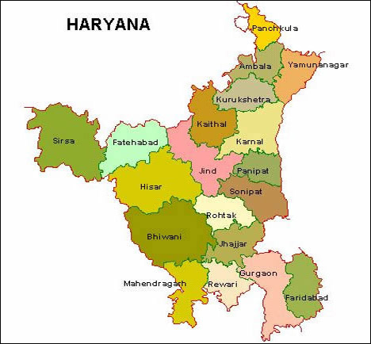



GOVERNMENT OF INDIA
Ministry of Agriculture
Department of Agriculture & Cooperation
(Mechanization & Technology Division)
ABBREVIATIONS
BIS = Bureau of Indian Standards
cm = Centimeter
deg = degree
F.E = Field Efficiency
h = hour
H = Height
ha = hectare
hp = Horse Power
ha/h = hectare per hour
kg = kilo gram
km = Kilometer
Km/h = kilo meter per hour
KVK = Krishi Vigyan Kendera
kW = Kilowatt
- = litre
L = length
m = meter
min = minute
ml = milli litre
man-h/ha = man hour per hectare
N = Newton
OECD = Organisation for Economic Cooperation & Development
Pits/h = Pits per hour
PTO = Power Take Off
rpm = Revolution per minute
Rs /pit = Rupees per pit
s = second
% = Percentage,
W = width

Sr. No. |  | Title / Chapter | Page No.
1.0 |  | Introduction | 1-2
a) |  | General Information | 1
b) |  | Agro and Sub Agro-climatic Zones | 1
c) |  | Climate | 1
d) |  | Land holding | 1
e) |  | Cropping pattern | 2
f) |  | Scope of farm mechanization | 2
2.0 |  | Suggested Agricultural Machinery and Equipment for Different Cropping Patterns | 3-7
a) |  | Rice – Wheat | 3
b) |  | Sugarcane – Wheat | 4
c) |  | Cotton – Wheat | 5
d) |  | Maize – Wheat | 6
e) |  | Maize – Oilseed – Pulses | 7
3.0 |  | Equipment for Land Development | 8-11
3.1 |  | Tractor drawn leveller | 9
3.2 |  | Laser guided land leveller | 10
3.3 |  | Tractor mounted Sub-soiler | 11
4.0 |  | Tillage Implements | 12-20
4.1 |  | M.B plough | 13
4.2  4.3 |  | Two bottom Reversible M.B plough  Disc plough | 14  15
4.4 |  | Tyne type cultivator | 16
4.5 |  | Trailed or mounted disc Harrow | 17
4.6 |  | Duckfoot cultivator | 18
4.7 |  | Rotavator | 19
4.8 |  | Pulverizing roller | 20
5.0 |  | Sowing and Fertiliser Application Equipment | 21-33
5.1 |  | Fertilizer Broadcaster | 22
5.2 |  | Seed-cum-fertilizer drill | 23
5.3 |  | Zero- till drill | 24
5.4 |  | Strip -till drill | 25
5.5 |  | Rapeseed-Mustard seed drill | 26
5.6 |  | Pneumatic multi-crop planter | 27
5.7 |  | Cotton planter | 28
5.8 |  | Ridge Planter for Maize | 29
5.9 |  | Ridger Seeder | 30
5.10 |  | Broad bed planter | 31
5.11 |  | Sugarcane cutter planter | 32
5.12 |  | Self-propelled rice transplanter | 33
6.0 |  | Interculture Equipment | 34-39
 | 6.1 | Dryland Peg weeder | 35
 | 6.2 | Wheel hand hoe | 36
 | 6.3 | Cono weeder | 37
 | 6.4 | Power tiller sweep tyne cultivator | 38
 | 6.5 | Self-propelled power weeder | 39
7.0 |  | Plant Protection Equipment | 40-44
 | 7.1 | Knapsack sprayer | 41
 | 7.2 | Motorised Knapsack mist blower cum duster | 42
 | 7.3 | Tractor mounted boom sprayer | 43
 | 7.4 | Aero-blast sprayer | 44
8.0 |  | Harvesting Equipment | 45-55
8.1 |  | Self propelled vertical conveyor reaper | 46
8.2 |  | Riding Type Self-propelled reaper | 47
8.3 |  | Tractor mounted vertical conveyer reaper | 48
8.4 |  | Self-propelled Combine harvester | 49
8.5 |  | Self-propelled Combine harvester for maize harvesting | 50
8.6 |  | Self-propelled reaper binder | 51
8.7 |  | Sugarcane harvester | 52
8.8 |  | Cotton picker | 53
8.9 |  | Straw reaper /Straw combine | 54
8.10 |  | Straw baler | 55
9.0 |  | Threshing Equipment | 56-59
 | 9.1 | Multi-crop thresher | 57
 | 9.2 | Axial- flow paddy thresher | 58
 | 9.3 | Maize De-husker cum sheller | 59
10.0 |  | List of Agriculture Machinery and Equipment Manufacturers in the State | 60-62
11.0 |  | Government of India Initiatives for promotion of agricultural mechanization | 63-65

(a) General Information:
Haryana in Northern India is located between 27° 37' to 30° 35' latitude and between 74° 28' to 77° 36' longitude. It is surrounded by Uttar Pradesh (UP) on the east, Punjab on the west, Uttaranchal, Himachal Pradesh & Shivalik Hills on the north and Delhi, Rajasthan and Aravali Hills on the south. The altitude of Haryana varies between 700 ft to 900 ft above the sea level. An area of 1,553 sq km is covered by forests. The state has a total of 81 cities & towns and 6,759 villages. For administrative purpose, the state has been divided into four divisions (Ambala, Rohtak, Gurgaon and Hissar) and 20 districts. The population of Haryana in 2001 was 2,11,44,564 comprising 1,13,63,953 males and 97,80,611 females. It formed 2.05% of India’s population. Population density in the State was 477/km².

(b) Agro and Sub Agro-Climatic Zones:
Haryana falls in the Agro Climatic Zone-VI, which is called “Trans-Gangetic Plains Region” The four main geographical features of the state are: Shivalik Hills, Ghaggar Yamuna Plain, Semi-desert sandy plain and Aravali hills. Rivers like Saraswati, Ghaggar, Tangri and Markanda originate from the Shivalik Hills. Ghaggar Yamuna Plain is made up of sand, clay, silt and hard calcareous balls like gravel known locally as “kankar”. This plain forms the largest part of the state. The other two regions are dry hilly areas and share its borders with Rajasthan. Most of the land of Haryana is flat, covered with loamy soil which is very suitable for agriculture. Haryana falls in the Seismic Zones II, III & IV creating low to moderate damage risk from Earthquakes. But the state comes under the “Cyclonic Zone” creating very high damage risk.
(c) Climate:
The State has three distinct seasons, viz. winter (November–March), summer (April–June) and Rainy season (July–October). The rainfall occurs during the months of July–September with occasional showers during December–January. The range of rainfall in this region varied between 160-751 mm. The summers are generally quite hot and winters are fairly cool.

(d) Land Holdings:
The total geographical area of Haryana is 4.421 million hectare and the area under forest is 45000 hectare. The cultivable area is 3.809 million hectare (86.2%of total geographical area) and the net area sown is 3.566 million hectare (93.6% of cultivable area). The gross cropped area is 6.504 million hectare and the area sown more than once is 2.938 million hectare with the cropping intensity of 182.39%. The net irrigated area is 2.936 million hectare (By canals- 45.3%, By Tube wells- 54.2% and by others – 0.5%). The gross irrigated area is 5.446 million hectare and the percentage of net irrigated sown area is 82.3%. The total number of land holdings is 15.28 lakh out of which 7.34 lakh (46.1%) are marginal farmers; average land holding is above 2 hectare.

(e) Cropping Pattern:
Haryana is often called the “Food Mine” of the country. About 80% of the population of the state is agriculture dependent, directly or indirectly. Haryana is self sufficient in producing food grains and is also a major contributor of food grains in meeting the needs of other states of the country. The world famous Basmati Rice is produced here in abundance. The major cereals produced in the state include wheat, rice, maize and bajra. The crop production of Haryana can be broadly divided into Rabi and Kharif. The main kharif crops in the state include sugarcane, groundnut, maize and paddy etc. The minor kharif crops are chillies, bajra, jawar, pulses and vegetables. The North Western part of the state is suitable for the cultivation of rice, wheat, vegetable and temperate fruits and the south-western part is suitable for high quality agricultural produce, tropical fruits, exotic vegetables and herbal and medicinal plants.

(f) Scope of Farm Mechanization:
The farm power availability in the State during the year 2001 was 2.25 kW/ha. However, a paradigm shift in agricultural mechanization is required to realize the goal of eco-friendly sustainable agriculture with reduced cost of production and high quality of produce. This is necessary to make the farmers globally competitive and to check further damage to natural resources of soil, water and ecology. Utmost emphasis is being laid in this state to expeditiously diversify agriculture by introducing new crops and cropping systems by shifting the area from the Paddy-Wheat cropping system which is the predominant cropping system prevalent in this State. Hence there are ample opportunities pertaining to agricultural mechanization. These include: introduction of new state-of-art farm tools and machines for new crops and ventures especially for horticulture, floriculture, rain-fed and organic farming. Equipment such as, sugarcane harvesting, cotton picking and potato harvesting need to be introduced in this state. Introduction of forage and fodder sowing and harvesting machinery and machinery for harvesting, collecting and management of crop residues of paddy and other crops is also necessary. Water harvesting, conserving machinery such as Laser guided land leveler, ridge and bed planter, tractor operated pond excavation machinery, drip and sprinkler irrigation systems also needs to be promoted.

A) Rice – Wheat

Sl.No. | Type of Machines | Approx. Price per unit  (Rs. in Lakh) | Description of the equipment (Page No.)
1. | Equipment for Land Development |  | 8
1. | Tractor drawn leveller | 0/20 | 9
1. | Laser guided land leveller | 3.50 | 10
1. | Tractor Mounted Sub-soiler | 0.20 | 11
2. | Tillage Implements |  | 12
2. | M.B plough | 0.30 | 13
2. | Two bottom reversible M.B plough | 0.60 – 1.20 | 14
2. | Disc plough | 0.30 | 15
2. | Tyne Type Cultivator | 0.25 -0.30 | 16
2. | Trailed or mounted type disc harrow | 0.35 | 17
2. | Rotavator | 0.80 | 19
3. | Sowing And Fertiliser Application Equipment |  | 21
3. | Fertilizer broadcaster | 0.12/0.025 | 22
3. | Seed-cum-fertilizer drill | 0.35 | 23
3. | Zero-till drill | 0.35 | 24
3. | Strip-till drill | 0.50 | 25
3. | Self propelled rice transplanter | 2.0 – 6.0 | 33
4. | Interculture Equipment |  | 34
4. | Dryland peg weeder | 0.008 | 35
4. | Cono weeder | 0.015 | 37
4. | Self-propelled power weeder | 0.60 – 0.70 | 39
5. | Plant Protection Equipment |  | 40
5. | Knapsack sprayer | 0.025 – 0.035 | 41
5. | Motorised Knapsack mist blower cum duster | 0.070 | 42
5. | Tractor mounted boom sprayer | 0.40 | 43
6. | Harvesting Equipment |  | 45
6. | Self propelled vertical conveyor reaper | 0.80 | 46
6. | Self-propelled riding type reaper | 1.20 | 47
6. | Tractor mounted vertical conveyor reaper | 0.45 | 48
6. | Self-propelled combine harvester | 14.0-16.0 | 49
6. | Self-propelled reaper binder | 2.0 | 51
6. | Straw combine/Straw reaper | 1.25 | 54
6. | Straw baler | 7.00 | 55
7. | Threshing Equipment |  | 56
7. | Multi-crop thresher | 0.60 – 0.80 | 57
7. | Axial-flow paddy thresher | 0.80 | 58

B) Sugarcane – Wheat

Sl.No. | Type of Machines | Approx. Price per unit  (Rs. in Lakh) | Description of the equipment (Page No.)
1. | Equipment for Land Development |  | 8
1. | Tractor drawn leveller | 0/20 | 9
1. | Laser guided land leveller | 3.50 | 10
2. | Tillage Implement |  | 12
2. | Two Bottom Reversible M.B plough | 0.60 – 1.20 | 14
2. | Disc Plough | 0.30 | 15
2. | Tyne Type Cultivator | 0.25 – 0.30 | 16
2. | Trailed or mounted type disc harrow | 0.35 | 17
2. | Rotavator | 0.80 | 19
2. | Pulverizing Roller | 0.30 | 20
3. | Sowing and Fertiliser Application Equipment |  | 21
3. | Fertilizer broadcaster | 0.12/0.025 | 22
3. | Seed-cum-fertilizer drill | 0.35 | 23
3. | Zero-till drill | 0.35 | 24
3. | Strip-till drill | 0.50 | 25
3. | Sugarcane cutter planter | 1.00 | 32
4. | Interculture Equipment |  | 34
4. | Dry land Peg Weeder | 0.008 | 35
4. | Power tiller sweep tyne cultivator | 0.15 | 38
4. | Self-propelled power weeder | 0.60 – 0.70 | 39
5. | Plant Protection Equipment |  | 40
5. | Knapsack sprayer | 0.025 – 0.035 | 41
5. | Motorised Knapsack mist blower cum duster | 0.070 | 42
5. | Tractor mounted boom sprayer | 0.40 | 43
5. | Aero-blast sprayer | 0.50 | 44
6. | Harvesting Equipment |  | 45
6. | Riding type self-propelled reaper | 1.20 | 46
6. | Tractor mounted vertical conveyor reaper | 0.45 | 48
6. | Self-propelled reaper binder | 2.00 | 51
6. | Self-propelled combine harvester | 12.0 – 14.0 | 49
6. | Straw combine /Straw reaper | 1.25 | 54
6. | Straw baler | 7.00 | 55
6. | Sugarcane harvester | 105 | 52
7. | Threshing Equipment |  | 56
7. | Multi-crop thresher | 0.60 – 0.80 | 57

C) Cotton –wheat

Sl.No | Type of Machines | Approx. Price per unit  (Rs. in Lakh) | Description of the Equipment (Page No.)
1. | Equipment for Land Development |  | 8
1. | Tractor drawn leveller | 0.20 | 9
1. | Laser guided land leveller | 3.50 | 10
2. | Tillage Implements |  | 12
2. | Two Bottom Reversible M.B plough | 0.60 – 1.20 | 14
2. | Disc Plough | 0.30 | 15
2. | Tyne Type Cultivator | 0.25 - 0.30 | 16
2. | Trailed or mounted disc harrow | 0.35 | 17
2. | Rotavator | 0.80 | 19
2. | Pulverizing roller | 0.30 | 20
3. | Sowing and fertiliser Application equipment |  | 21
3. | Fertilizer broadcaster | 0.12/0.025 | 22
3. | Seed-cum-fertilizer drill | 0.35 | 23
3. | Zero-till drill | 0.35 | 24
3. | Strip-till drill | 0.50 | 25
3. | Cotton planter | 0.30 | 28
4. | Interculture Equipment |  | 34
4. | Dryland peg weeder | 0.008 | 35
4. | Power tiller sweep tyne cultivator | 0.15 | 38
4. | Self-propelled power weeder | 0.60 – 0.70 | 39
5. | Plant Protection Equipment |  | 40
5. | Knapsack sprayer | 0.025 – 0.035 | 41
5. | Motorised Knapsack mist blower cum duster | 0.070 | 42
5. | Tractor mounted boom sprayer | 0.40 | 43
5. | Aero-blast sprayer | 0.50 | 44
6. | Harvesting Equipment |  | 45
6. | Self-propelled vertical conveyor reaper | 0.80 | 46
6. | Tractor mounted vertical conveyer reaper | 0.45 | 48
6. | Self-propelled combine harvester | 14.0 – 16.0 | 49
6. | Self-propelled reaper binder | 2.00 | 51
6. | Straw reaper /Straw combine | 1.25 | 54
6. | Straw Baler | 7.00 | 55
6. | Cotton picker | 15 -25 | 53
7. | Threshing Equipment |  | 56
7. | Multi-crop thresher | 0.60 – 0.80 | 57

D) Maize- Wheat

Sl.No | Type of Machines | Approx. Price per unit  (Rs. in Lakh) | Description of the Equipment(Page No.)
1. | Equipment for Land Development |  | 8
1. | Tractor drawn leveller | 0.20 | 9
1. | Laser guided land Leveller | 3.50 | 10
2. | Tillage Implement |  | 12
2. | Two Bottom reversible M.B plough | 0.60 – 1.20 | 14
2. | Disc plough | 0.30 | 15
2. | Tyne type cultivator | 0.25 -0.30 | 16
2. | Trailed or mounted type disc harrow | 0.35 | 17
2. | Rotavator | 0.80 | 19
2. | Pulverizing Roller | 0.30 | 20
3. | Sowing and Fertiliser Application Equipment |  | 21
3. | Fertilizer broadcaster | 0.12/0.025 | 22
3. | Seed-cum-fertilizer drill | 0.35 | 23
3. | Zero-till drill | 0.35 | 24
3. | Strip-till drill | 0.50 | 25
3. | Ridge planter for maize | 0.35 | 29
4. | Interculture Implement |  | 34
4. | Dryland peg weeder | 0.008 | 35
4. | Self-propelled power weeder | 0.60 – 0.70 | 39
5. | Plant Protection Equipment |  | 40
5. | Knapsack sprayer | 0.025 – 0.035 | 41
5. | Motorised Knapsack mist blower cum duster | 0.070 | 42
5. | Tractor mounted boom sprayer | 0.40 | 43
5. | Aero-blast sprayer | 0.50 | 44
6. | Harvesting Equipment |  | 45
6. | Self-propelled vertical conveyor reaper | 0.80 | 46
6. | Tractor mounted vertical conveyor reaper | 0.45 | 48
6. | Self-propelled reaper binder | 2.00 | 51
6. | Self-propelled combine harvester for maize | 12.0 to 14.0 | 50
6. | Straw reaper / Straw combine | 1.25 | 54
6. | Straw baler | 7.00 | 55
7. | Threshing Equipment |  | 56
7. | Multi-crop thresher | 0.60 – 0.80 | 57
7. | Maize de-husker- cum sheller | 0.60 | 59

E) Maize – Oilseeds – Pulses

Sl.No | Type of Machines | Approx. Price per unit  (Rs. in Lakh) | Description of the equipment (Page No.)
1. | Equipment for Land Development |  | 8
1. | Tractor drawn leveller | 0.20 | 9
1. | Laser guided land leveller | 3.50 | 10
2. | Tillage Implement |  | 12
2. | Two Bottom Reversible M.B plough | 0.60 – 1.20 | 14
2. | Disc plough | 0.30 | 15
2. | Tyne type cultivator | 0.25 -0.30 | 16
2. | Trailed or mounted type disc harrow | 0.35 | 17
2. | Rotavator | 0.80 | 19
2. | Pulverizing roller | 0.30 | 20
3. | Sowing Equipment |  | 21
3. | Fertilizer broadcaster | 0.12/0.025 | 22
3. | Pneumatic multi-crop planter | 0.50 | 27
3. | Seed-cum-fertilizer drill | 0.35 | 23
3. | Zero-till drill | 0.35 | 24
3. | Strip-till drill | 0.50 | 25
3. | Rapeseed/ Mustard seed drill | 0.35 | 26
3. | Ridger seeder | 0.35 | 30
3. | Broad bed planter | 0.40 | 31
4. | Interculture Implement |  | 34
4. | Dryland peg weeder | 0.008 | 35
4. | Self-propelled power weeder | 0.60 | 39
5. | Plant Protection Equipment |  | 40
5. | Knapsack sprayer | 0.025 – 0.035 | 41
5. | Motorised Knapsack mist blower cum duster | 0.070 | 42
5. | Tractor mounted boom sprayer | 0.40 | 43
5. | Aero-blast sprayer | 0.50 | 44
6. | Harvesting Equipment |  | 45
6. | Self-propelled vertical conveyor reaper | 0.80 | 46
6. | Tractor mounted vertical conveyor reaper | 0.45 | 48
6. | Self-propelled reaper cum binder | 2.00 | 51
6. | Self-propelled combine for maize | 12.0 – 14.0 | 50
7. | Threshing Equipment |  | 56
7. | Multi- crop thresher | 0.60 – 0.80 | 57
7. | Maize de-husker cum sheller | 0.60 | 59

3.1 | Tractor Drawn Leveller
3.2 | Laser Guided Land Leveller
3.3 | Tractor Mounted Sub-Soiler

3.1 TRACTOR DRAWN LEVELLER

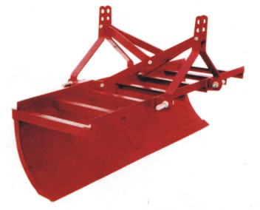
Features

The leveler consists of frame, 3-point linkage, cutting or scraping blade, and thick curved sheet closed from sides to form a bucket. The scraping blade is made from medium carbon steel or low alloy steel, hardened and tempered to about 42 HRC. The blade is joined to the curved sheet with fasteners and can be replaced after being worn out or becoming dull. The working depth of the implement is controlled by hydraulic system of the tractor.

Specifications:
Length( mm) | : 1840
Width (mm) | : 700
Height (mm) | : 700
Size of Blade (mm)  -Length  -Width  -Thickness | : 1830  : 75  ; 8
Weight (kg) | : 90
Power requirement (hp/kW) : 35/26.25

Uses: Leveling of fields and pulling or pushing loosened soil from one place to other.
Approx Cost: Rs. 20,000

3.2 LASER GUIDED LAND LEVELLER

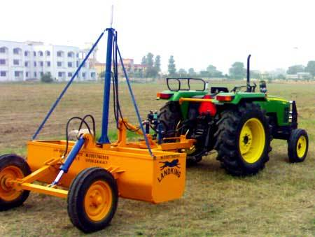
Features:

The laser land leveler consists of a laser transmitter, a laser receiver, an electrical control panel, a twin solenoid hydraulic control valve, two wheels and a leveling bucket. The laser transmitter transmits a laser beam, which is intercepted by the laser receiver mounted on the leveling bucket. The control panel mounted on the tractor interprets the signal from the receiver and opens or closes the hydraulic control valve, which raises or lowers the bucket. Some laser transmitters have the ability to operate over graded slopes ranging from 0.01% to 15% and apply dual controlled slope in the field. The leveling bucket can be either 3-point linkage mounted or pulled by the tractor’s drawbar. Bucket dimensions, number of wheels and capacity will vary according to the available power source and field conditions.

Specifications:
Laser Source | : < 5mw 635nm
Operating diameter( m) | : (Above) 800
Grade range ( %) | : –10 to +15 Dual Axes
Grade accuracy ( %) | : 0.015, 3 mm@30 m
Remote control type | : Full 2-way communication
Power requirement ( hp/KW) : 60/45

Uses: It is used for precision leveling of land in one or both the directions.

Approx Cost: Rs.3,50,000
3.3 TRACTOR MOUNTED SUB-SOILER

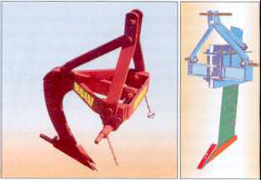
Features:

It consists of beam made of high carbon steel, beam supports which are flanged at upper and lower edges for rigidity, hollow steel adaptor welded to the bottom end of the beam to accommodates share base having square section, share plate made from high carbon steel and shank drilled and counter bored for set board which secures the base in the adaptor. Share plate is made from high carbon steel, hardened and tempered to suitable hardness. Two symmetrically located bolt holes allow reversibility of share. The working depth of the sub-soiler is controlled by hydraulic system and linkage of tractor.
Specifications:
Length (mm) : 600
Width (mm) : 490
Height (mm) |  | : 1325
Maximum working depth (mm) |  | : 535
Weight (kg) |  | : 62
Power requirement(hp/kW) |  | : 55/41.25
Uses: It is used to break hardpan of the soil, loosening of the soil and helps the water to seep into the soil for improving drainage. A mole ball can be attached to create a small tunnel in the soil, which serves as drainage channel for water.

Approx. Cost of Machine : Rs.20,000/-

4.1 | M.B plough
4.2 | Two Bottom Reversible M.B Plough
4.3  4.4 | Disc Plough  Tyne Type Cultivator
4.5 | Trailed or Mounted Type Disc Harrow
4.6 | Duck Foot Cultivator
4.7 | Rotavator
4.8 | Pulverizing Roller

4.1 M.B PLOUGH

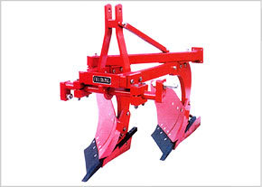
Features
It is a tractor-operated implement and consists of share point, share, mould board, landslide, frog, shank, frame and three point hitch system. The share point is of bar type and is made from high carbon steel or low alloy steel. The share is also made from high carbon steel or low alloy steel. Both are hardened and tempered to suitable hardness (about 45 ARC). The working of the plough is controlled by hydraulic system lever and three-point linkage. Its bar point makes it suitable to break hardpan of the soil.

Specifications:  Length (mm)  Width (mm)  Height (mm)  Weight (kg)  Power requirement ( hp/kW) | : 1778  : 889  : 1092  : 253  : 45/33.75
Uses: It is used for primary tillage operations. It cuts trash and buries it completely into the soil. It is also used for turning green manure crop for decaying under the soil, which adds humus to the soil. It is also used for turning and mixing compost, farmyard manure or lime into the soil.

Approx. Cost of Machine : Rs.30,000/-

4.2 TWO BOTTOM REVERSIBLE M.B PLOUGH
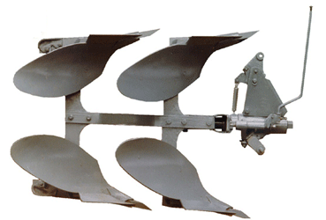
Features:
The two bottom reversible plough is a unique implement, which is directly mounted to the tractor. This is a hydraulically /mechanically operated basic implement for preparation of land. It is very useful for primary tillage in hard and dry trashy land. The Mould Board (M.B) retains their mirror finish at all time contributing to well turned furrows. The plough has special wear resistant steel bottoms with bar points for toughest ploughing jobs. Bar point bottom ensures longer life as it can be extended or reversed. The mould board bottom reversing mechanism is operated by a lever provided on the distributor. When the implement is hitched, plough bottom is free to rotate 180 degree along the axis of the hollow shaft.
Specifications  Length (mm)  Width (mm)  Weight (kg)  Plough bottom  Reversing mechanism  Speed of operation (km/h)  Area covered (ha / h)  Field efficiency (%) | : 320  : 367 (at front)  : 260  : Four (Two on each side)  : Hydraulically/ Mechanically operated  : 3 to 4  : 0.20 to 0.25  : 90
Power requirement (hp/kW) : 65/48.75 & above tractor

Uses: It is used for primary tillage operation and does not leave any dead furrow or uneven and sunken spots in the field. The bottoms are so arranged that the right turning bottoms can be quickly replaced with a set that turns the soil to the left.

Approx. Cost: Rs. 60,000- 1,20,000/-

4.3 DISC PLOUGH
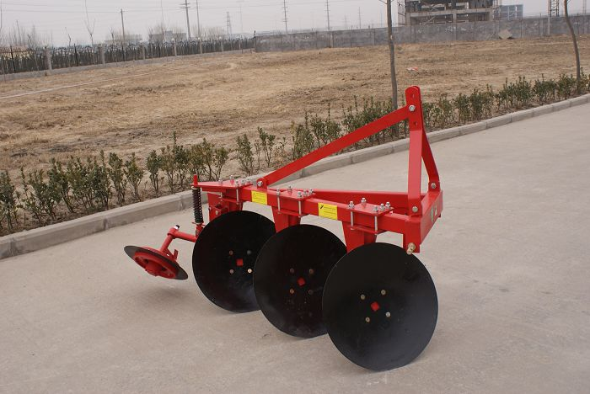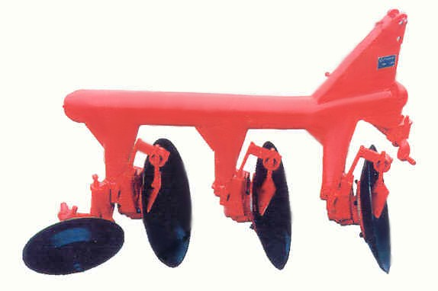
Features
The plough consists of common mainframe, disc beam assemblies, rockshaft category –l or category -2, a heavy spring loaded furrow wheel and a gauge wheel. In some models disc plough is designed to operate as 2, 3 or 4 bottom, by adding or removing the sub-beam assemblies according to requirement. The disc angle ranges from 40 to 45⁰ to obtain the desired width of cut and the tilt angle ranges from 15 to 25⁰ for penetration. The discs of the plough are made of high carbon steel or alloy steel and the edges are hardened and sharpened. The discs are mounted on tapered roller bearings. Scrapers prevent soil build up on the discs in sticky soils. The furrow slice rides along the curvature and is pulverized to some extent before being thrown.

Specifications  Number of furrows  Disc size (mm)  Length (mm)  Width (mm)  Height (mm)  Width of cut per disc (mm)  Adjustable working width (mm)  Working depth (mm)  Weight (kg))  Power requirement (hp/kW) | : 2-4  : 600-800  : 1180-2362  : 889-1194  : 1092-1118  : 200-300  : 600-1200  : up to 300  : 236-376  : 35-50/26.25-37.5, tractor
Uses: Disc plough is used for primary tillage operation and is especially useful in hard and dry, trashy, stony or stumpy land conditions and in soil where scouring is a major problem.
Approx. Cost of Machine :Rs. 30,000/-

4.4 TYNE TYPE CULTIVATOR

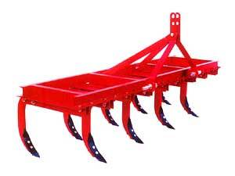 |  | 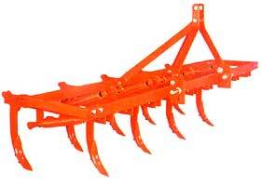
Features

Cultivator consists of a frame, tynes fixed with reversible shovels, 3-pont hitch system and heavy-duty springs. These cultivators may or may not be fitted with springs. The function of springs is to save the cultivator tynes from breaking when some hard object comes in contact with the shovel or under the tyne. The shovels are made of heat-treated steel for longer life. The implement is mounted type and is controlled by the hydraulic system of the tractor.

Specifications  Length(mm)  Width (mm)  Height (mm)  Number of tynes  Diameter of spring wire (mm)  Power requirement (hp/kW) | : 1960-3000  : 970-1560  : 1070-1350  : 9-13  : 9.5  : 35/26.5, tractor
Uses: Cultivators are used for seedbed preparation both in dry and wet soils. It is also used for intercultural purpose by adjusting the tynes in wider row crops. It is also used for puddling purposes.

Approx. Cost of Machine : Rs. 25,000 – Rs. 30,000/-

4.5 TRAILED OR MOUNTED DISC HARROW
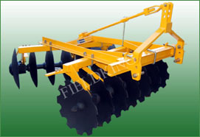 | 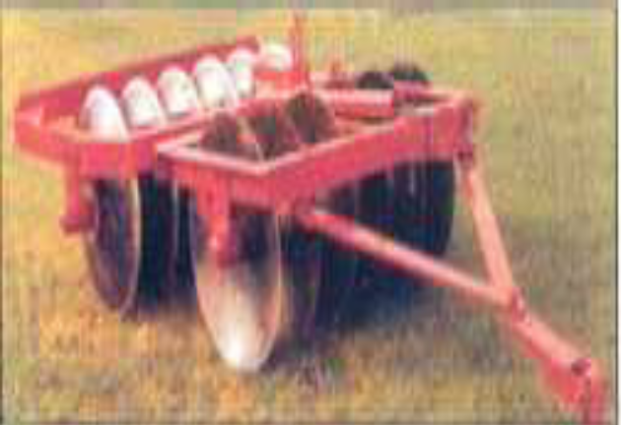
Features:
The tractor mounted disc harrow consists of two gangs of discs mounted one behind the other. The discs on the front gang throw soil outward and the rear gang inward. Therefore, no soil remains uncut by the offset disc harrow. The harrow consists of a sturdy frame, discs arranged in two gangs, and three-point linkage. Discs are important component of the harrow and are made from high carbon steel or alloy steel; the cutting edges are hardened and tempered to suitable hardness. The gangs can be moved in either direction on the hitch frame. The rear gang can be moved the same amount as the front gang. When operating in orchards or plantations, the harrow can be offset to the right or left, thus enabling soil to be thrown towards or away from the trees and makes it possible to work under low–hanging branches. Discs with notches on the outer rim are also available for operation in weed-infested fields. Three point hydraulic linkage and hydraulic control makes it highly maneuverable.

Specification:  Length (mm)  Width (mm)  Height (mm)  Number of discs  Diameter of discs (mm)  Pitch of discs:  Weight (kg)  Capacity (ha/day)  Power requirement (hp/kW) |  | : 1980-2260  : 1150-1900  : 1143-1350  : 10-16  : 457-660  : 228-280  : 330-490  : 2.5  : 20-60/15-45
Uses: The disc harrow is used for primary and secondary tillage operations. It is ideal for field disking, especially in orchards, plantations and vineyard. It is suitable for working under trees close to the bunds and fence posts.
Approx. Cost of Machines: Rs. 35,000/-

4.6 DUCKFOOT CULTIVATOR
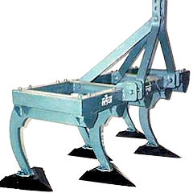
Features

The duckfoot cultivator consists of a box type steel rectangular frame, rigid tynes and sweeps. The sweeps are triangular in shape similar to foot of duck, hence called duckfoot cultivator. The sweeps are made from old leaf spring steel and fixed to tynes with fasteners, which makes them replaceable after being worn out or becoming dull. The tynes are made of mild steel flat and forged to shape. It is a tractor-mounted implement and depth of operation is controlled by hydraulic system. The sweep cultivator is popular in black cotton soils. This cultivator is mostly used in hard soils for shallow ploughing.

Specification  Number of sweeps  Length (mm)  Width (mm)  Height (mm)  Weight (Kg) | : 5,7,9  : 1980-2810:  : 830-1150  : 1000-1050  : 200 -300
Power requirement (hp/kW) : 25-50/18.75-37.5, tractor

Uses: Used for primary tillage operation, destruction of weeds and retention of soil moisture.

Approx. Cost of Machine : Rs. 25,000/-

4.7 ROTAVATOR

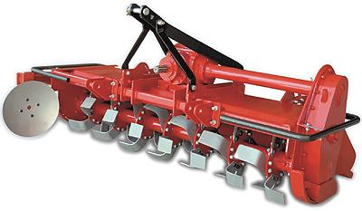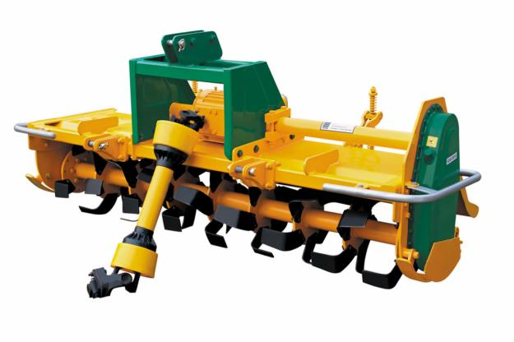
Features
It consists of a steel frame with three point hitch system, a rotary shaft on which blades are mounted, power transmission system, and gearbox. The blades are of L-shape, made from medium carbon steel or alloy steel, hardened and tempered to suitable hardness. The PTO of tractor drives the rotavator blades. Rotary motion of the PTO is transmitted to the shaft carrying the blades through gearbox and transmission system. A good seedbed and pulverization of the soil is achieved in a single pass of the rotavator. The power requirement will vary depending upon the width of the rotavator. The horse power of the tractor used will depend on the size of the rotavator.
Specifications:  Length (mm) :  Width (mm) :  Height (mm) :  Working width of rotavator (mm) :  Shape of blade :  Orientation of blade (degrees) :  Length of blade along the flange (mm) :  Length of blade along the rotor shaft (mm) :  Distance between consecutive flanges (mm) :  Total number of flanges :  Number of blades per flange :  Diameter of rotor shaft (mm) :  Rotor diameter (mm) :  Revolution of rotor shaft (rpm) :  Weight (kg) : | 1760-2080  950-1050  935-1110  1000-2000  L-Shape  45 -47  160-170  115-130  213-220  6-8  6  70-90  420-435  210-237  280-415
Power source(hp/kW) : 35-50/26.25-37.5, tractor
Uses: It is suitable for preparing seedbed in a single pass both in dry and wetland conditions. It is also suitable for incorporating straw and green manure in the field.

Approx. Cost of Machine : Rs. 80,000/-

4.8 PULVERISING ROLLER
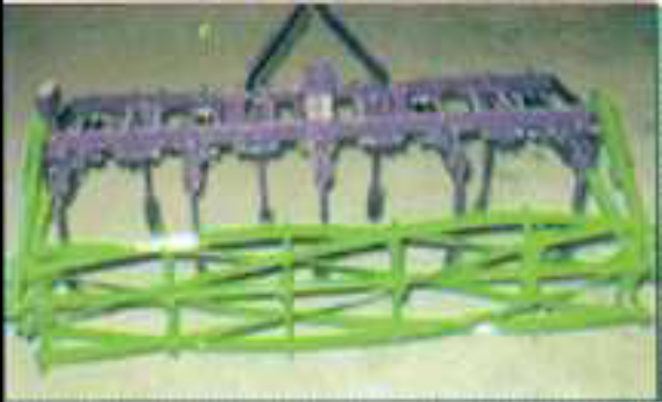
Features

Pulverizing roller is an attachment to a commercially available cultivator. The pulverizing roller consists of star wheels, central shaft, pulverizing members, mounting link and depth controlling wheel. The pulverizing members are similar in shape to lawn mower blades and are inserted in the cast star wheels in such a way that it forms helical shape and progressively come in contact with soil and breaks it. The roller is attached to the cultivator with the help of two mounting links having bearing housing on one side and tensile springs on other side.

Specifications:  Length (mm)  Width (mm)  Height (mm)  Working width (mm)  Number of star wheels  Distance between star wheels (mm)  Material of star wheel  Shaft diameter (m)  Number of pulverizing members  Number of springs  Weight of the machine (kg)  Power requirement (hp/kW) | : 950  : 2340-2760  : 390  : 2010-2385  : 6  : 400-475  : Cast iron  : 35  : 6  : 2  : 115-125  : 35/26.25, tractor or above
Uses: Pulverizing rollers are used for puddling as well as dry seed bed preparation. In two runs it creates good puddled field. It saves 20-35 % fuel consumption and 20-30 % water requirement in comparison to traditional method.
Approx. Cost of Machine : Rs. 30,000/-

5.1  5.2 | Fertilizer Broadcaster  Seed-Cum-Fertilizer Drill
5.3 | Zero-Till Drill
5.4 | Strip-Till Drill
5.5 | Rapeseed-Mustard Seed Drill
5.6 | Pneumatic Multi-Crop Planter
5.7 | Cotton Planter
5.8  5.9 | Ridge Planter for Maize  Ridger Seeder
5.10 | Broad bed planter
5.11 | Sugarcane Cutter Planter
5.12 | Self -Propelled Rice Transplanter

5.1 FERTILIZER BROADCASTER

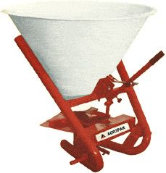  Tractor Mounted |  | 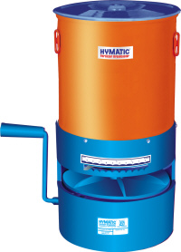  Manual
Features
This equipment is used for broadcasting of granular fertilizer and small seeds of crop as well. The equipment is available in hand operated as well as tractor operated version. The hand operated broadcaster is kept in front of the operator with the help of shoulder straps provided with it and can be operated with the help of a lever. The tractor operated version is rear mounted and is operated by its PTO. The broadcaster, both versions, mainly consists of a hopper and a spinning disc. The seed or fertilizer from the hopper is made to fall on the spinning disc rotating at high speed, which in turn spreads the seed /fertilizer, uniformly all around due to centrifugal force. The flow of the material to the spinning disc can be controlled by a shutter plate.

Specifications:  Tractor Operated  Power Source: Agricultural tractor  35hp/26.5 kW  Hopper Capacity: 300 Kg  Weight of Machine : 100 Kg  Height of machine: 180 cm  Area covered: 2.50 ha/h | Manually Operated  One person  Hopper Capacity : 10 kg  Weight: 4 Kg  Overall dimension (length, width and  height) = 41 cm, 38.5 cm and 41 cm.  Area covered: 1.0 ha/h
Uses: Broadcasting of granular fertilizer and seeds.

Approx. Cost of Machine : Rs. 12000 (Tractor Operated) and Rs. 2500/- (Manual)

5.2 SEED-CUM-FERTILIZER DRILL
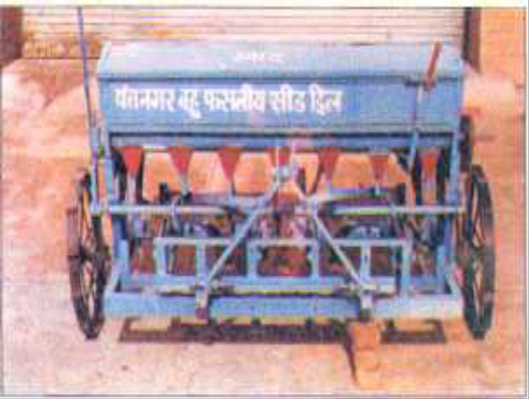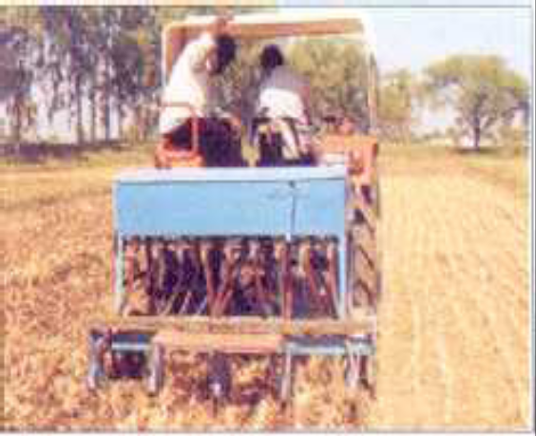
Features:
The seed cum fertilizer drill consists of a seed box, fertilizer box, seed and fertilizer metering mechanisms, seed tubes, furrow openers , seed and fertilizer rate adjusting lever and transport cum power transmitting wheel. The fluted rollers are driven by a shaft which gets power from wheels. Fluted rollers fixed in the seed box, receive the seeds into longitudinal grooves and drop them in the seed tube attached to the furrow opener. By shifting the rollers sideways, the length of the grooves exposed to the seed, can be increased or decreased and hence the amount of seed sown can be varied.

Specifications  Length (mm)  Width (mm)  Height (mm)  Seed metering mechanism  Fertilizer metering mechanism  Number of furrow opener  Furrow opener  Size of feed shaft (mm)  Size (diameter) and number of flutes  Seed box capacity (cm³)  Fertilizer box capacity (cm³)  Weight (kg) | : 1940-2310  : 970-1560  : 1070-1350  : Fluted roller  : Gravity feed with agitator  : 9-13  : Reversible shovel  : 16-19  : 42.7-49.2 and 9-11  : 66241-10308  : 63310-10141  : 224-328
Power source (hp/kW) : 35/26.25, tractor

Uses: Seed cum fertilizer drills are used for sowing of wheat and other cereal crops in already prepared field

Approx. Cost of Machine : Rs. 35,000/

5.3 ZERO-TILL DRILL

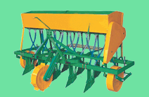
Features:
Zero-till-drill consists of frame, seed box, fertilizer box, seed metering mechanism, fertilizer metering mechanism’, seed tubes, furrow opener seed/fertiliser adjusting mechanism and transport cum power transmitting wheel. The frame is made from mild steel box section. The tynes are mounted with the help of clamps, to obtain infinite row spacing. The main difference between zero-till drill and conventional drill is that it has inverted T-type furrow opener fixed on the tynes instead of reversible shovels type furrow opener. The main advantage of inverted t-type furrow openers is non formation of clods, lower draft requirement and easier penetration in the soil.

Specifications  Length (mm)  Width (mm)  Height (mm)  Seed metering mechanism  Fertilizer metering mechanism  Power transmission  Furrow opener  No of furrow opener  Size of fertilizer shaft (mm)  Seed box capacity (cm3)  Fertilizer box capacity (cm3)  Weight (kg)  Power requirement(hp/KW) | : 1960-2310  : 970-1560  : 1070-1350  : Fluted roller  : Adustable opening with agitator  : Chain and sprockets  : Inverted T -type  : 9-13  : 20-22.3  : 66241-10308  : 63310-10141  : 150- 220  : 35/26.25, tractor
Uses: Zero-till-drills are used for sowing wheat crop in unprepared field after harvesting of paddy.

Approx. Cost of Machine : Rs. 35,000/-

5.4 STRIP-TILL DRILL
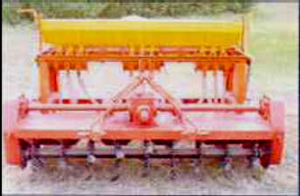
Features:

Strip-drill consists of a standard seed drill with a rotary attachment mounted in the front. The rotary system has C-type blades, which prepare a 75 mm wide strip in the front of every furrow opener. Thus with every row, 125 mm of the strip is left untilled and only 40 percent of area is tilled. Tilling and sowing is done simultaneously.
Specifications  Length (mm)  Width (mm)  Height (mm)  Seed metering mechanism  Fertilizer metering mechanism  Power transmission  Furrow opener  Number of flanges on the rotary  Number of blades on each flange  Type of blade  Opening width of blade (mm)  Number of furrow opener  Size of feed shaft (mm)  Size (diameter), mm and number of flutes  Seed box capacity (cm³)  Fertilizer box capacity (cm³)  Ground wheel diameter (mm)  Weight (kg)  Source of power (hp/kW) | : 1960-2310  : 970-1560  : 1070-1350  : Fluted roller  : Gravity fed with an agitator  : Chain and sprockets  : Inverted T -type /reversible shovel  : 9-11  : 6  : C type  : 75  : 9-11  : 16-19  : 42.7-49.2 and 9-11  : 66241-10308  : 63310-10141  : 390-450  : 220-330  : 35-45 /26.25- 33.75, Tractor
Uses: It is used for sowing wheat after paddy without any prior seed bed preparation. It can save 50-60 % fuel and 65-75 % time as compared to conventional method The machine also helps in increasing the yield because of timely sowing of crop.
Approx. Cost of Machine : Rs. 50,000/-

5.5 RAPESEED-MUSTARD SEED DRILL

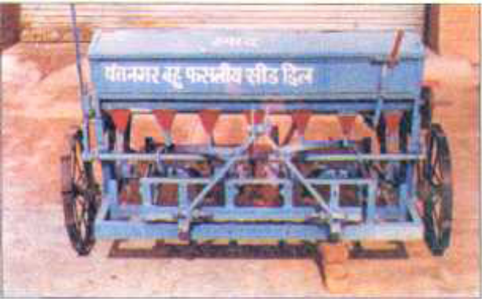
Features:
The rapeseed-mustard drill consists of mild steel angle iron frame, seed hopper, fluted roller mechanism for metering of seeds, lugged ground wheels, power transmission system, seed tubes and furrow openers. The seed drill is tractor drawn implement. The fluted rollers are specially designed for metering of rapeseed-mustard seeds. The fluted roller is 50 mm in diameter and has 10 grooves of 2 x 2 mm slots. Adjusting seed metering mechanism can vary the seed rate. The operation of seed drill is similar to other seed cum fertilizer drills.
Specifications  Weight (kg) :  Number of rows :  Furrow opener  Seed rate (kg/ha)  Width of coverage (mm)  Depth of placement (mm)  Operating speed (km/h)  Field capacity (ha/h)  Field efficiency (per cent)  Labour requirement (man-h/ha)  Power requirement (hp/kW) | : 120  : 4  : Hoe type  : 3.0-4.00  : 1500  : 30-40  : 5-7  : 0.6  : 62  : 3-4  : 30/22.5, tractor
Uses: It is suitable for sowing of small seed such as, rapeseed, mustard and millets.

Approx. Cost of Machine : Rs. 35,000/-

5.6 PNEUMATIC MULTI-CROP PLANTER
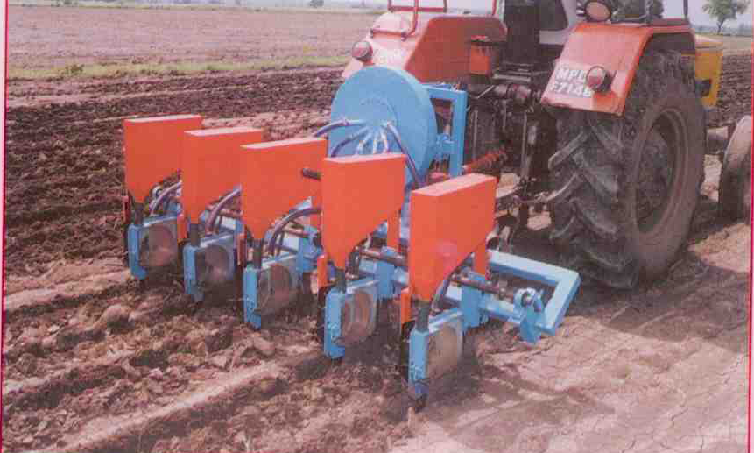
Features:

Tractor mounted pneumatic planter consists of a centrifugal blower operated by the PTO of a tractor which is used to provide the necessary air pressure to pick up and release the seeds in the metering mechanism. It is a six-row (2 or 4 optional) machine, operated by a tractor of 35 hp/26.25 kW or more to plant single seed at predetermined seed/row spacing. It consists of main frame, aspirator blower, disc with cell type metering plate, individual hopper, furrow openers, PTO driven shaft, ground drive wheel etc. It is suitable to plant seeds of mustard ,sorghum ,soybean cotton, pigeon pea, maize, groundnut, okra etc
Specification:  Overall Dimensions  Length x Width x Height (mm)  Weight (kg)  Draft(N)  Working width (mm)  Working depth (mm)  Operating speed (km/h)  Field capacity (ha/h)  Field efficiency (%)  Power requirement(hp/kW) | : 1450 x 2450 x1250  : 200  : 2000  : 2000-3000  : 0-5.0  : 3.0 to 5.0  : 0.5-1.0  : 60-65  : 35/26.25, tractor
Uses: It is used to plant individual seeds at the pre-determined seed/row spacing.

Approx. Cost of Machine : Rs. 50,000/-

5.7 COTTON PLANTER
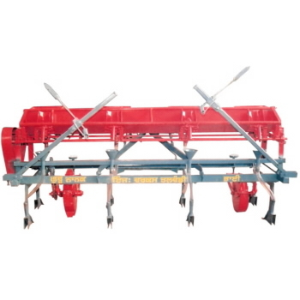
Features:

The planting attachment consists of a hopper, inclined plate metering mechanism fitted in the hopper, furrow openers, ground wheel, power transmission mechanism, seed tubes and. marker devices. For operation, the cotton seed is filled in the hopper, seeds are picked up by the cells of inclined plate and delivered in the opening connected to furrow opener through seed tubes. It can plant 4- 6 rows of cotton at a spacing of 60-90 cm in addition to number of other crops like maize, soybean, sunflower etc. Seed-metering mechanism in planting attachment is of inclined plate type with notched cells on the periphery for each row. Row to row spacing and plant-to-plant spacing is adjustable. Plant to plant spacing can be varied by changing the transmission ratio. The drive to the metering mechanism is given through the ground wheel by means of chains, sprockets and bevel gears
Specifications  Length (mm)  Width (mm)  Height (mm)  Number of rows  Row to row spacing (mm)  Power requirement (hp/kW) | : 970  : 2500  : 1120  : 4  : 600 -900 (adjustable)  : 35 /26.25, tractor
Uses: Sowing of cotton and other bold seeds like maize, soybean, sunflower

Approx. Cost of Machine : Rs. 30,000/-

5.8 RIDGER PLANTER FOR MAIZE
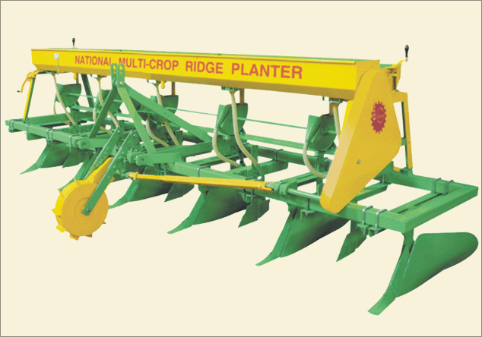
Features:

It is a tractor-operated implement and consists of seed hopper, seed metering plate, chain drive system, seed tubes, ground wheel, furrow opener, ground wheel tension spring, ridger bottom and ridger beam. The seed-metering device is of inclined plate type and has cells on its periphery. The ridger body consists of two mould boards (M.B.) and share mounted in the front. The share is made of medium carbon steel or alloy steel, hardened and tempered to suitable hardness. The seed metering mechanism receives power from the ground wheel. During operation, the cells of inclined plate pick up one or two seeds and drop it on the top/side of the ridge through a seed tube. The planting unit is mounted on commercially available ridger.
Specifications  Dimensions (l x W x H) (m)  Number of rows  Weight (Kg)  Seed metering device  Furrow opener  Width of coverage (mm)  Depth of placement (mm)  Operating speed (km/h)  Field capacity (ha/h)  Field efficiency (per cent)  Power requirement (hp/kW) | : 0.77 x 1.53 x 1.04  : 4-6  : 70  : Inclined plate  : Reversible shovel  : 1200  : 30-40  : 2.0-2.5  ; 0.20-0.25  : 60-70  : 45/33.75, tractor
Uses: It is suitable for planting maize crop and other similar crops on one side of ridges.
Approx. Cost of Machine : Rs. 35,000/-

5.9 RIDGER SEEDER

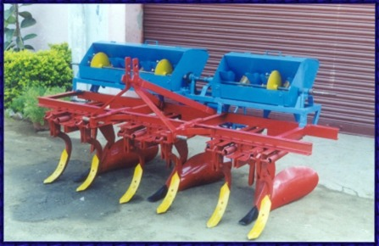
Features:

The unit consists of a tilling mechanism having 6 numbers of cultivator tynes with shovels, a ridging mechanism having 3 numbers of adjustable ridgers and a planter having seed hopper with cup feed seed metering device for seed, ground wheel, transmission system and row markers. Separate furrow openers and closers are eliminated in this unit. The row spacing can be altered by fixing the ridger bottoms and cultivator tynes to the appropriate holes provided in the main frame, The plant spacing can be varied by changing the sprockets or the number of cups in the seed metering disc. The desired depth of seed placement can be obtained by moving the seed tube.
Specification:  Type  Overall dimensions(mm)  Seed metering  Weight(kg)  Capacity(ha/h)  Power requirement(hp/kW) | : Tractor mounted  : 2400 x 1750 x 1100  : Cup feed type  : 300  : 0.40  : 35/26.25, tractor
Uses: It is used for making ridges and furrows. In kharif sowing can be done on ridges and in rabi season the sowing can be done in the furrows.

Approx. Cost of Machine : Rs. 35,000/-

5.10 BROAD BED PLANTER

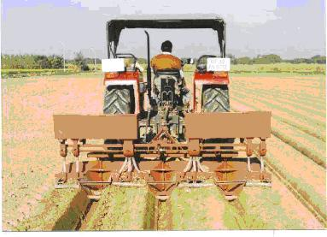
Features:

The broad bed planter consists of a frame, planting hoppers, fertilizer box, furrow openers, bed shaper and power transmitting wheel. The frame is made of mild steel sections. The furrow openers are ridger type and have mould board and share point. The wings of the mould board can be adjusted. The share is made of medium carbon steel or alloy steel, hardened and tempered to suitable hardness. The machine makes two beds. Machine can sow two or three rows of wheat on each bed. Machine has seed metering unit of vertical disc type. The draft requirement of the machine is reduced due to roller type bed shaper
Specification:  Length (mm)  Width (mm)  Height (mm)  Seed metering mechanism  Fertilizer metering mechanism  Power transmission seed metering  Furrow openers  Bed shaper  Number of rows for sowing wheat per bed  Weight (kg)  Power required (hp/kW) | : 2850  : 1700  : 1440  : Vertical disc type with grooves  : Vertical disc type with grooves  : Chain and sprockets  : Ridger type  : Roller type  : 2-3  : 400  : 35/26.25 or above tractor
Uses: Bed planter makes bed and sows crops simultaneously and suitable for wheat, maize, peas etc. Vegetables seeds can also be sown by the planter.
Approx. Cost of Machine : Rs. 40,000/-

5.11 SUGARCANE CUTTER PLANTER

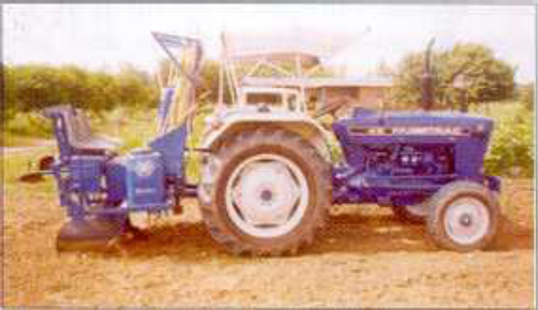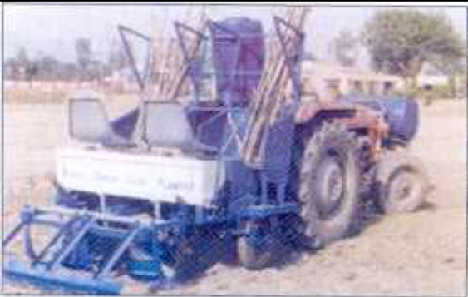
Features:
It is a whole stick sugarcane cutter planter and consists of ridger body attached to frame, sett cutting unit, fertilizer application unit, chemical application unit, sett covering unit and seed box. The whole planter carries its total weight on two rubber tyres. While in transportation mode, wheel allows the machine to be transported to the planting site and while planting, load is carried by the wheels, which ensure desired depth of penetration and weight of the machine making tractor hydraulic lift free. Cutting of the cane into 350 mm length is done automatically in the machine and sett is treated with insecticides at the cutting point. The sets are placed in the furrow created by ridger bodies automatically with overlapping upto 30%. The pesticide is also sprayed on the ends of sett in the furrows. The seed placed in the furrow is covered immediately after the chemical treatment and rows are leveled by the leveler provided at the rear of the machine. The machine is tractor PTO driven.
Specifications  Length (mm) :  Width (mm) :  Height (mm) :  Number of rows :  Row to row spacing (mm) :  Sett cutting mechanism :  Seed placement :  Field capacity (ha/day) :  Capacity of fertilizer box (kg) :  Capacity of seed box (kg) :  Capacity of insecticide tank (lit.) :  Power requirement(hp/kW) : | 2130  2030  2135  2  600-750  Automatically  Regularly with 50 mm overlap  2-2.4  50  400  100  35-50/26.25-37.50, tractor
Uses: It is used for planting of sugarcane. It cuts the seed sett of desired length, opens the furrows, places the sett in the furrow opened, applies fertilizer, chemical treatment of sett and covers the sett simultaneously.
Approx. Cost of Machine : Rs. 1,00,000/-

5.12 SELF-PROPELLED RICE TRANSPLANTER
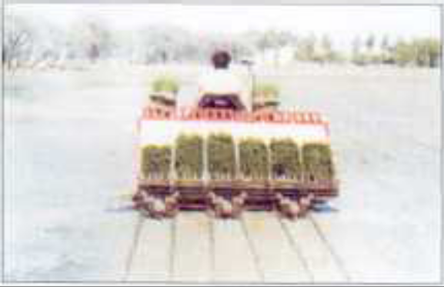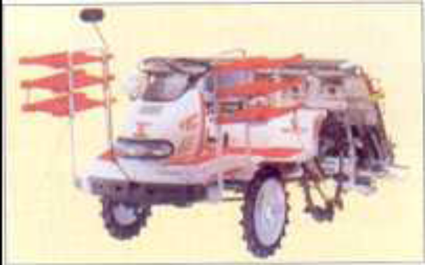
Features:

It is a six-row rice transplanter using mat type seedlings. The six row machine is a riding type and employs a double acting transplanting mechanism for enhanced transplanting speed and in turn high field capacity. The double acting transplanting mechanism is run with, one sun and four planetary gears. The machine has provision for adjustments of number of seedlings per hill, depth of transplanting and hill-to-hill distance. The depth of transplanting is maintained constant, automatically -during transplanting. The row-to-row spacing is 300 mm and five setting of hill to-hill distance from 120 to 220 mm can be fixed depending on desired plant population. The machine is provided with six spare seedling racks for filling of trays intermittently. The machine is powered with a 12 hp air cooled petrol engine and it is provided with power steering. Depth of transplanting can be set from 15 to 45 mm. It is also available in walking type version and in some cases also provided with a seat.
Specifications  Overall length (mm)  Overall width (mm)  Overall height (mm)  Weight (kg)  Engine type  Maximum output (rpm)  Starting method  Steering,  Transplanting section  Number of rows  Planting width (cm)  Transplanting speed (m/sec) | : 3020  : 2140  : 1530  : 570  : 4-cycle, air-cooled OHV gasoline  : 1200-1800  : Electric  : Power steering  : 6  : 30  : 0.24-1.3
Uses: It is used for transplanting of mat type rice nursery in the puddle field.
Approx. Cost of Machine : Rs. 2-6 lakhs

6.1 | Dryland Peg Weeder
6.2 | Wheel Hand Hoe
6.3 | Cono Weeder
6.4 | Power Tiller Sweep Tyne Cultivator
6.5 | Self-Propelled Power Weeder

6.1 DRYLAND PEG WEEDER

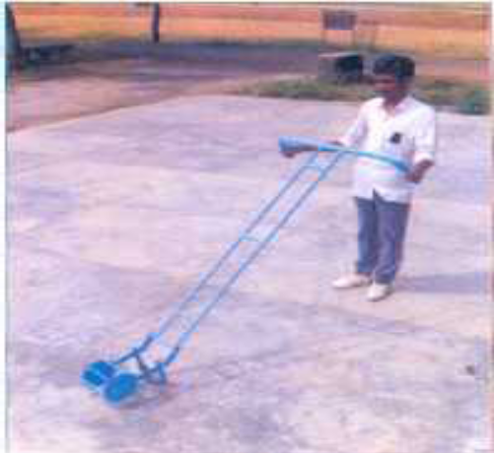
Features:

The dry land weeder (peg type) is manually operated weeder suitable for operation between the crop rows. It consists of a roller, which has two mild steel discs joined by mild steel rods. The small diamonds shaped pegs are welded on the rods in a staggered fashion. The complete roller assembly is made of mild steel. The V shaped blade follows the roller assembly and is mounted on the arms. The height of the blade can be adjusted according to the working depth. The arms are joined to the handle assembly, which is made from thin walled pipes. The height of the handle can also be adjusted according to the requirement of the operator. For removing weeds it is repeatedly pushed and pulled in between the crop rows in the standing position. The diamonds shaped pegs penetrate into the soil and the rolling action pulverize the soil. The blade in the push mode penetrates into the soil and cuts or uproots the weeds.

Specifications:  Overall length (mm)  Overall width (mm)  Overall height (mm)  Diameter of the peg wheel (mm)  Working width (mm)  Weight (kg) | : 1680  : 590  : 1080  : 220  : 150  : 8-10
Uses: The weeder is used for removing weeds in vegetable gardens, basins of orchard trees and Vineyard plantations. It is also used for breaking the soil crust and creation of soil mulch.

Approx. Cost of Machine: Rs. 800/-

6.2 WHEEL HAND HOE

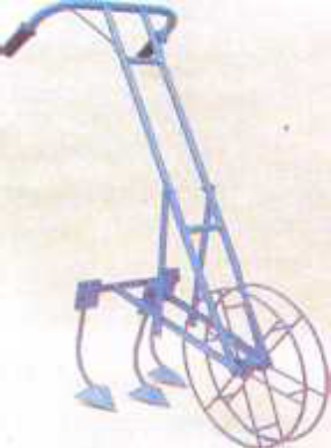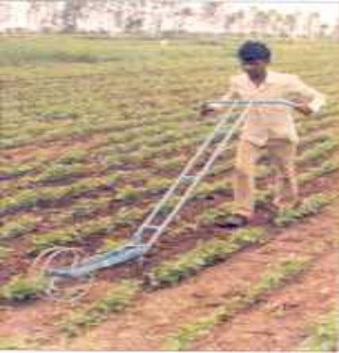
Features:

The wheel hand hoe is a widely accepted weeding tool for doing weeding and interculture in row crops. It is a long handled tools operated by pushing and pulling action. The number of wheel varies from one to two and the diameter depends upon the design. The frame has provision to accommodated different types of soil working tools such as, straight blade, reversible blades, sweeps, V -blade, tyne cultivator, pronged hoe, miniature furrower, spike harrow (rake) etc. It can be operated by a single person. All the soil working components of the tool are made from medium carbon steel and hardened to 40-45 HRC. For operation, the working depth of the tool and handle height is adjusted and the wheel hoe is operated by repeated push- pull action which allows the soil working components to penetrate into the soil and cut/uproot the weeds in between the crop rows. With this action, the weeds also get buried in the soil.

Specifications:  Overall length (mm) :  Overall width (mm) :  Overall height (mm) :  Number of tynes :  Wheel diameter (mm) :  Working depth (mm) :  Weight (kg) : | : 1400- 1500  : 450- 500  : 800- 1000  : 3 No.  : 200- 600  : Upto 60  : 4- 12
Uses: For weeding and intercultural operations in vegetables and other crops sown in rows.

Approx. Cost of Machine : Rs. 1200/-

6.3 CONO WEEDER

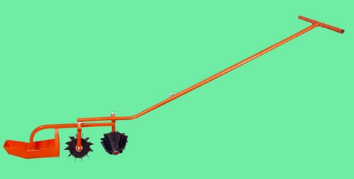
Features:

The weeder consists of two rotors, float, frame and handle. The rotors are cone frustum in shape, smooth and serrated strips are welded on the surface along its length. The rotors are mounted in tandem with opposite orientation. The float, rotors and handle are joined to the frame. The float controls working depth and does not allow rotor assembly to sink in the puddle. The cono weeder is operated by pushing action. The orientation of rotors create a back and forth movement in the top 3 cm of soil and helps in uprooting the weeds.

Specifications:  Width (mm)  Height (mm)  Type  Weight (kg)  Number of rotors  Capacity (ha/day)' | : 370  : 1400  : Manually operated  : 5 to 6  : 2  : 0.18
Uses: The cono weeder is used to remove weeds between rows of paddy crop efficiently. It is easy to operate, and does not sink in the puddle.

Approx. Cost of Machine : Rs. 1500/-

6.4 POWER TILLER SWEEP TYNE CULTIVATOR

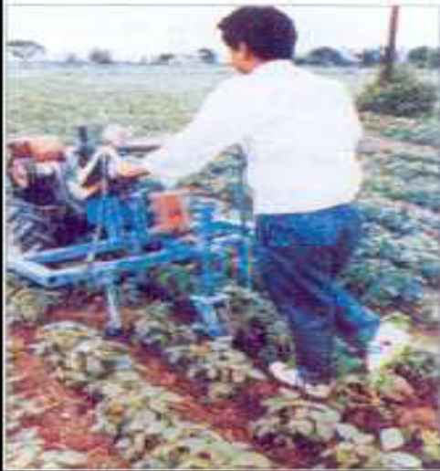
Features:
This machine has been specially designed for operation with a power tiller of 5-8 hp (4.5-6.0 kW) to perform interculture operations in standing crop in soybean, sorghum, bengal gram, pigeon pea etc where the row spacing is wide enough for the power tiller to pass without damaging the plants. A depth control wheel is provided at its rear for maintaining uniform depth of operation. It is suitable for medium and light soils. It is provided with a ground wheel for operating the metering mechanism. Some of its major components are the main frame with hitch system, handle, and drive wheel and tynes.

Specifications:  Overall Dimensions  Length (mm)  Width (mm)  Height (mm)  Weight (kg)  Working width (mm)  Working depth (mm)  Weeding efficiency (%)  Operating speed (km/h)  Fuel consumption (l/h)  Field capacity (ha/h)  Power Source(hp/kW) | : 930  : 1580  : 1370  : 40  : 1350  : 50  : 50-60  : 1.8-2.5  : 0.7-1.0  : 0.18-0.25  : 5-8/4.5-6.0, engine
Uses: It is used for performing interculture operations in standing crop in soybean, sorghum, Bengal gram, pigeon pea etc.
Approx. Cost of Machine : Rs. 15,000/-
6.5 SELF-PROPELLED POWER WEEDER

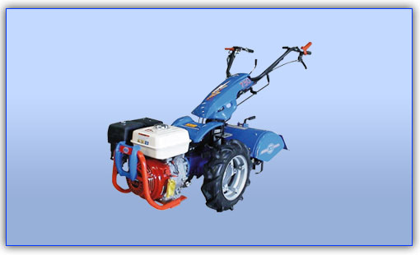
Features

A diesel engine operates the weeder. The engine power is transmitted to ground wheels through V belt-pulley. A tail wheel is provided at the rear to maintain the operating depth. Weeding is done by the rotary weeding attachment. The rotary weeder consists of three rows of discs mounted with 6 numbers of curved blades in opposite directions alternatively in each disc. These blades when rotating enable cutting and mulching the soil. The width of coverage of the rotary tiller is 500 mm and the depth of operation can be adjusted for weeding and mulching the soil in the cropped field.

Specification:
Type  Overall dimensions(LxWXH)  Weight  Capacity  Power requirement(hp/kW) |  | : Self propelled  : 2400 x 1750 x 1100 mm  : 200 Kg  : 1 - 1.2 ha per day  : 3-5/2.25-3.75 Diesel/petrol engine
Uses: Useful for weeding between rows of crops like tapioca, cotton, sugarcane, maize, tomato and pulses having row spacing more than 45 cm. Attachments like sweep blades, ridger, trailer can be attached with the machine.

Approx. Cost of Machine: Rs. 60,000 -70,000/-

7.1 | Knapsack sprayer
7.2 | Motorised Knapsack mist blower cum duster
7.3 | Tractor mounted boom sprayer
7.4 | Aero-blast sprayer

7.1 KNAPSACK SPRAYER

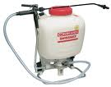
Features:
Knapsack sprayer consists of a pump and air chamber permanently installed in a 9 to 22.5 liters tank. The handle of the pump extending over the shoulder or under the arm of operator makes it possible to pump with one hand and spray with the other. Uniform pressure can be maintained by keeping the pump in continuous operation.

Brief Specifications:  Tank capacity (l)  Pump cylinder inner dia (mm)  Number of piston in pump cylinder  Pressure chamber capacity (ml)  Displacement volume (ml)  Number of delivery spout  Type of delivery spout  Cut off valve passage diameter (mm)  Lance length (mm)  Nozzle type  Spray angle  Size of filling hole (mm)  Pump discharge (ml/min)  Power required | : 9-22.5  : 39-42  : One  : 572-660  : 87.24  : One  : Threaded  : 5  : 725  : Hollow cone  : 78 degree  : 94.9  : 610-896  : One person
Uses: Knapsack sprayers are used for spraying insecticides and pesticides on small trees, shrubs and row crops.

Approx. Cost of Machine : Rs. 2,500-3,500/-

7.2 MOTORISED KNAPSACK MIST BLOWER CUM DUSTER

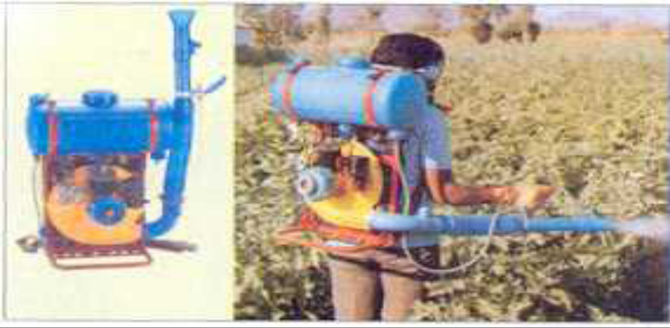
Features:
It consists of two plastic tanks (fuel and water/dust), engine, pump, spray hose, rope starter, delivery pipe, cut-off-cock, shoulder straps and a frame. It has a small 2-stroke petrol/kerosene engine of 35 cc to which a centrifugal fan is connected. The fan produces a high velocity air stream, which is diverted through a 90-degree elbow to a flexible (plastic) discharge hose, which has a divergent outlet. Upon rotation of the engine the fan produces a high velocity air stream. The control valve for the spray is opened gradually and adjusted for the desired flow rate. The operator directs the discharge hose to the target. It can be converted for dusting and ULV application.

Specification:  Length (mm)  Width (mm)  Height (mm)  Weight (kg)  Number of tanks  Air velocity at outlet(m/s)  Field capacity(ha/h)  Power requirement (hp/kW) | : 460  : 210  : 540  : 9-11  : 2  : 65-75  : 2-3  : 1.2/0.9 ,petrol or petrol/kerosene  engine
Uses: It is suitable for spraying pesticides and fungicides. It is used for spraying in rice, fruits and vegetable crops. It can be used for applying pesticides in liquid and powder form.

Approx. Cost of Machine : Rs. 7000/-

7.3 TRACTOR MOUNTED BOOM SPRAYER

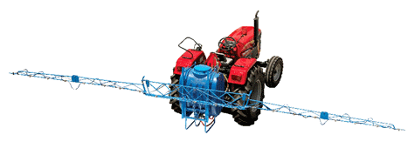
Features:

The sprayer essentially consists of a tank made of fiber glass or plastic, pump assembly’s suction pipe with strainer, pressure gauges, pressure regulators, air chamber, delivery pipe and spray boom fitted with nozzles. The sprayer is mounted on 3-point linkages of the tractor. The hydraulic energy sprayers utilize PTO power of the tractor to operate the pump of the sprayer. Basically the spray boom can be arranged in two ways; ground spray boom and overhead spray boom. The overhead spray boom is designed for spraying in tall field crops and the planting is done in such a way that an unplanted strip of about 2.5 m width is left for operation of the tractor. Therefore a planted strip may be 18-20 m wide and after every planted strip a fallow strip has to be left for tractor operation. For ground spray boom the planting has to be done in rows keeping in view track width of the tractor. It uses high pressure and high discharge pump as the number of nozzles may be up to 20 depending upon the crop and make of the sprayer.

Specifications:  Overall length(mm)  Overall width (mm)  Overall height (mm)  Tank capacity (l)  Weight (kg)  Field capacity (ha/day)  Power Source (hp/KW) | : 6340  : 1290  : 1570  : 400  : 150-200  : 8 (with 13 nozzles)  : 25-35/17.5-22.5, tractor or above
Uses: It is used for spraying in vegetable gardens, flower crops, vineyards and for tall field crops like sugarcane, maize, cotton, sorghum, millets etc.

Approx. Cost of Machine : Rs. 40,000/-
7.4 AERO-BLAST SPRAYER

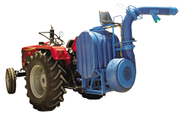
Features:

The machine consists of tank of 400 litres capacity, pump, fan, control valve, filling unit, spout, adjustable handle and spraying nozzles to release the pesticide solution in to stream of air blast produced by the centrifugal blower. The air blast distributes chemical in the form of very fine particles throughout its swath. The major portion of swath is taken care of by the main blast through the main spout and the auxiliary nozzles cover the swath area near the tractor. The sprayer is mounted on the tractor 3-point linkage and is operated by tractor PTO. The orientation of air outlet can be adjusted for its direction and width of coverage.

Specifications:  Type of power (rpm)  Crops suitability  Type of blower  Flow rate (l/min)  Spray rate (l/ha)  Spray swath (m)  Working speed (km/h)  Tank capacity (l)  Machine weight (kg)  Power required (hp/kW) | : Tractor PTO at 540  : Cotton, sugarcane, horti. crops  : Centrifugal  : 120  : 100-400  : 15 (without wind)  : 2-6  : 400  : 230  : 35/26.25 or above
Uses
It is useful for spraying on horticultural crops and crops like cotton, sunflower, sugarcane etc.

Approx. Cost of Machine : Rs. 50,000/-

8.1 | Self Propelled Vertical Conveyor Reaper
8.2 | Riding Type Self-propelled Reaper
8.3 | Tractor Mounted Vertical Conveyer Reaper
8.4 | Self-propelled Combine Harvester
8.5 | Self-propelled Combine Harvester for Maize
8.6 | Self-Propelled Reaper Binder
8.7 | Sugarcane Harvester
8.8 | Cotton Picker
8.9 | Straw Reaper/Straw Combine
8.10 | Straw Baler

8.1 SELF- PROPELLED VERTICAL CONVEYOR REAPER
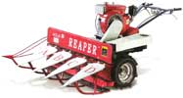
Features:
It is an engine operated, walk behind type harvester suitable for harvesting and windrowing cereals and oilseed crops. The reaper consists of engine, power transmission box, pneumatic wheels, cutter bar, crop row dividers, conveyor belts with lugs, star wheels, operating controls and a sturdy frame. The engine power is transmitted to cutter bar and conveyor belts through belt pulleys. During forward motion of the reaper, crop row dividers divide the crop, which come in contact with cutter bar, where shearing of crop stems takes place. The cut crop is conveyed to one side of the machine by the conveyor belt fitted with lugs and is windrowed in the field. The crop is bundled manually and transported to threshing yard. There are no shattering losses due to vertical conveying of the crop.

Specifications:  Dimensions (LxWxH) (mm)  Weight (kg)  Number of crop dividers  Length of cutter bar (mm)  Cutter bar pitch (mm)  Number of strokes/min  Power requirement (hp/kW) | : 2450 x 1200 x 1000  : 145  : 4  : 1000  : 75  : 700 (0.8 m/s average speed)  : 5/3.75, diesel engine
Uses: It is suitable for harvesting rice, wheat, soybean and other cereals and oilseeds.

Approx. Cost of Machine : Rs. 80,000/-

8.2 RIDING TYPE SELF- PROPELLED REAPER
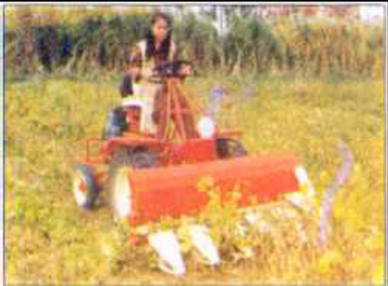
Features:

The riding type vertical conveyor reaper is a self-propelled unit in which the operator rides on the machine. Drive is given by means of two large pneumatic wheels and steering is by rear idlers. The prime mover is a 6 hp/4.5 kW diesel engine. Convenient clutch, brake, steering, hydraulic system and simple power transmission are provided for ease of operation. It consists of crop row divider, star wheel, cutter bar (76.2 mm); conveyor belt and wire spring etc. This reaper has two forward and one reverse speed. The crop after being cut is dropped in a windrow on the side.

Specifications:  Overall Dimensions  Length (mm)  Width (mm)  Height (mm)  Weight (kg)  Operating speed (km/h)  Total grain losses (%)  Field capacity (ha/h)  Fuel consumption (l¼h)  Field efficiency (%)  Labour requirement (man-h/ha)  Power requirement(hp/kW) | : 3185  : 1900  : 1450  : 1530  : 3.0-3.5  : 5.0-5.9  : 0.25-0.30  : 0.90-1.15  : 60-70  : 5-6  : 6/4.5, engine
Uses: It is suitable for harvesting rice, wheat, soybean and other cereals and oilseed crops.

Approx. Cost of Machine : Rs. 1,20,000/-

8.3 TRACTOR MOUNTED VERTICAL CONVEYOR REAPER

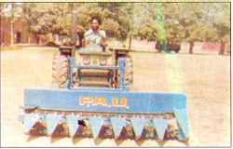
Features:
The machine consists of a 76 mm pitch reciprocating cutter bar assembly, seven crop row dividers, two vertical conveyor belts fitted with lugs, pressure springs, pulleys and gearbox for the power transmission system. The crop row dividers are fitted in front of the cutter bar assembly and the star wheels are mounted over the crop row dividers. The machine is mounted in front of the tractor and the power to the machine is given from tractor PTO with the help of intermediate shaft running beneath the chassis of the tractor and a coupling shaft. Height of the machine above ground is controlled by tractor hydraulics with the help of pulleys and steel ropes. After the crop is cut by the cutter bar, it is held in a vertical position and crop is delivered to one side of the machine by lugged belt conveyors and fall on the ground in the form of a windrow perpendicular to the direction of movement of the machine.
Specifications  Number of star wheels  Diameter of star wheel (mm)  Effective cutter bar width (mm)  Guard spacing (mm)  Cutter bar stroke length (mm)  Stroke per minute  Size of belt conveyer (cm)  Width of belt (mm)  Diameter of conveyor pulley (mm)  Cutter bar length (mm)  Weight (kg)  Power source (hp/kW) | : 7  : 270-282  : 2000-2210  : 70-80  : 75-80  : 388-675  : 2-3 ply  : 55-60  : 118-140  : 1600-2010  : 197-350  : 35/26.5, tractor
Uses: Vertical conveyor reaper is used for harvesting and windrowing of wheat and paddy crops.
Approx. Cost of Machine : Rs. 45,000/-

8.4 SELF-PROPELLED COMBINE HARVESTER
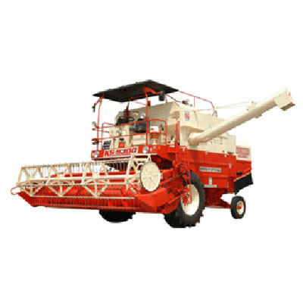 | 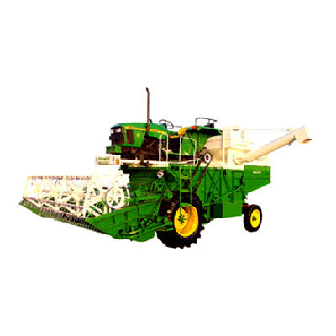
Features;

The combine harvester consists of cutting unit, threshing unit and cleaning and grain handling units. The cutting section includes reel, cutter bar, an auger and a feeder conveyer. Threshing section has threshing cylinder, concave and cylinder beater. The cleaning section mainly consists of walker, chaffer sieve, grain collection pan. The grain handling section consists of a grain elevator and a discharge auger. The crop after being cut is delivered to the cylinder and concave assembly through feeder conveyor where it is threshed and the grains and straw is separated in different sections. The grain can be directly loaded into the trolley.
Specifications:  Cutter bar length (mm)  Cutting height (mm)  Threshing drum diameter (mm)  Threshing drum length (mm)  Threshing drum speed (rpm)  Length of upper sieve (mm)  Width of upper sieve (mm)  Length of lower sieve (mm)  Width of lower sieve (mm)  Grain tank capacity (cubic meter)  Road speeds (km/h)  Weight (kg)  Power Source (hp) |  | : 4300  : 550-1250  : 605  : 1240  : 540-1050  : 1240  : 1215  : 1240  : 1215  : 3.28  : 2 -11.4  : 8200  : 90-110
Uses: Combines are used for cutting, threshing, cleaning of cereal and other crops in one operation.

Approx. Cost of Machine : Rs. 14-16 lakhs

8.5 SELF PROPELLED COMBINE HARVESTER FOR MAIZE
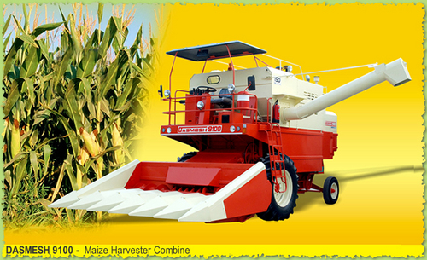
Features:
The combine harvester consists of a cutting unit, threshing unit and cleaning and grain handling units. The cutting section is specially designed to harvest maize crop and the header can be fitted to conventional grain combines. Threshing section has threshing cylinder, concave and cylinder beater. The cleaning section mainly consists of walker, chaffer sieve, grain collection pan. The grain handling section consists of a grain elevator and a discharge auger. The crop after being cut is delivered to the cylinder and concave assembly through feeder conveyor where it is threshed and the grains and straw is separated in different sections.
Specification:  Cutter Bar Width (mm)  Cutting Height (mm)  No. of Rows  Row Spacing (mm)  Size of threshing drum, Dia. x Length (mm)  Type of Threshing drum  Speed of threshing drum (rpm)  Concave Clearance (mm)  Number of Straw Walkers  Area of straw walkers (m²)  Cleaning area (m²)  Overall Dimension (L x B) (mm)  Min. Ground Clearance (mm)  Weight (kg).  Working capacity (ha/h)  Power requirement(hp/kW) |  |  | : 3650  : 100- 1000  : 5/7  : 460- 685  : 600 x 1260  : Rasp Bar  : 535 to 1210rpm  : 3-16  : 5  : 0.89  : 25  : 1500 x 4500  : 460  : 9000  : 1.00  : 75-110 56-82, Engine
Uses: Maize Combine is used for cutting, threshing and cleaning of maize and can be used for harvesting other cereal crops in one operation by changing the header.
Approx. Cost of Machine : Rs. 12-14 lakh

8.6 SELF-PROPELLED REAPER BINDER
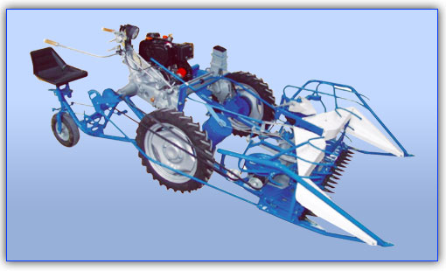
Features:
Reaper-Binder is a unique harvesting machine that reaps the crop as well as binds it simultaneously with a twine. This Innovative Mechanical machine ensures 100% recovery of straw with negligible grain losses at a surprisingly low cost of operation. This machine is mainly used in Wheat, Paddy, Oats, Barley and other grain crops.

Specifications:  Width of Cut (mm)  Height of Cut (mm)  Area Covered (ha/h)  Engine(hp/kW)  Gear  Weight of Machine (Kg) | : 1200  : 30-50  : 0.4  : 10.2 /5.1 Air Cooled Diesel  : 4 Forward & 1 Reverse  : 400
Uses:

- Harvesting and Binding of Grain Crops in a single operation.
- Used for grain crops of height up to 85 to 110 cm.
- Harvesting and binding of 0.40 ha field in 1 hour, with consumption of 1 liter diesel only.
- Different cutter bar can also be attached to the same machine for harvesting berseem, mentha, lucern, paddy stubbles and other fodder crops.

Approx. Cost of Machine : Rs. 2,00,000/-
8.7 SUGARCANE HARVESTER
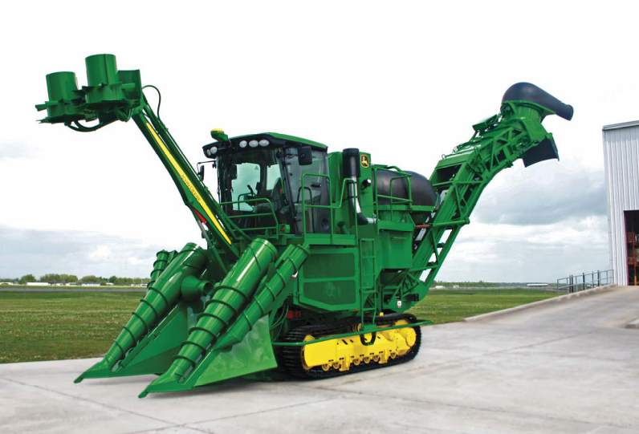
Features:
It is a chopper harvester with a cleaning system and whole cane harvesters are also available. It can cut one/two rows of cane at a time. The cane is fed between the crop dividers and is cut at the root zone by base cutter blades and simultaneously de-topped from top. The cane is then fed through the roller train and is cut by the chopper drums into small cane pieces of 24.5 to 30 cm. It is then cleaned in the primary extractor before being conveyed on the elevator. The can is then cleaned again with the secondary extractor and loaded onto a vehicle for transportation. In ideal conditions, the harvester can cut nearly 400 tonnes of sugarcane per day.
Specification:  Transmission :  Tyres :  Tracks :  Primary Extractor :  Hood rotation :  Elevator :  Overall dimension (l x w x h) (m) : Engine Power (hp/kW) : | Two hydrostatic pumps providing variable speed (Wheel machine: 0 to 24.6 km/h) (Track machine: 0 to 9.0 km/h)  Front 14x17.5 - 14 Ply, Rear 23.5x25 - 20 Ply  Sealed track chains  Polyethylene plastic 152 cm  Hydraulically controlled  Loading to either side  15.14 x 2.50 x 6.23  337/252.75
Uses: It is used for harvesting sugarcane. It de-tops the cane from the top, cuts it from the base, strips the cane, cuts it into billets, removes the trash and simultaneously loads the cut billet into the trolley moving by its side.

Approx. Cost of Machine : Rs. 105 lakh/-
8.8 COTTON PICKER
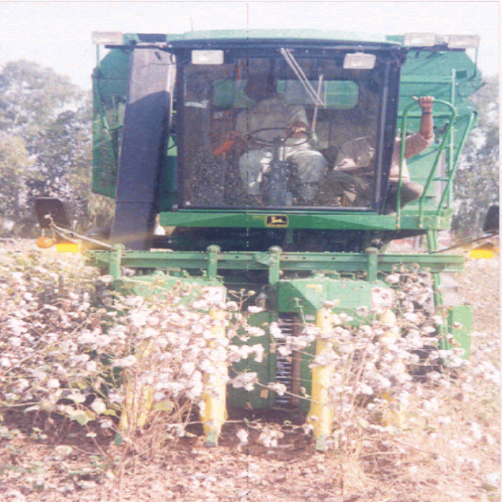

Features:
Cotton picker machines, often called spindle-type harvesters, remove the cotton from open bolls and leave the bur on the plant. The spindles, which rotate on their axes at high speeds, are attached to a drum that also turns, causing the spindles to penetrate the plants. The cotton fibers are wrapped around the moistened spindles and then removed by a special device called a doffer; the cotton is then delivered to a large basket carried above the machine.
Specifications:
Forward Speed(km/h) : 2.92- 5.0
Effective Field Capacity (ha/day) : 2.24- 4.4
Machine picking efficiency (%) : 75 – 95
Fuel consumption( lit/h) : 22

Uses: Picking of Cotton from the cotton bolls.

Approx. Cost: Rs. 15 -25 lakhs

8.9 STRAW REAPER/ STRAW COMBINE
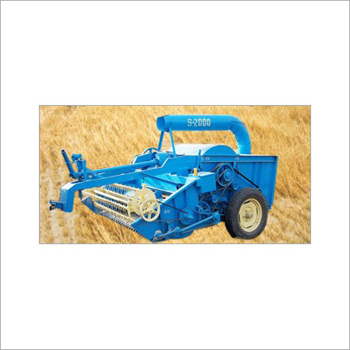
Features:
Straw combine operated by tractor PTO has cutter bar reel, feeding auger and bruising cylinder like a traditional thresher. Straw thrown and stubble left by the grain combine is collected by straw combine and delivered to the cylinder concave section, where it is cut into pieces and passed through the concave. A reciprocating cutter bar is used for reaping the standing stubbles and the portion of the straw left uncut by the combine harvester. Straw, which passes through the concave, is aspirated by a blower and fed into a trolley on rear side covered by a wire net. For recovering the left grains from the straw, a sieve system is provided below the concave.
Specifications:  Length (mm)  Width (mm)  Height (mm)  Length of cutter bar  Height of cut  Diameter of reel (mm)  Width of reel (mm)  Width/Dia. of threshing drum (mm)  Threshing drum speed (rpm)  Blower diameter (mm)  Blower width (mm)  Number of blowers  Machine capacity (ha/h)  Power requirement (hp/kW) | : 3370-5350  : 2145-2400  : 2210  : 1830  : 60  : 435-485  : 1920-1935  : 1025-1250/525-625  : 650  : 660  : 230  : 1-2  : 0.40  : 35/26.25 tractor or above
Uses: Straw combines are used to recover wheat straw left standing after combine operation. It also helps in recovering about 50 kg grain per hectare.

Approx. Cost of Machine : Rs. 1,25,000/-

8.10 STRAW BALER
INCLUDEPICTURE "http://c.tkcdn.com/images/uploadedimages/offers/3/1/B3559029-20091103120131.jpg" \* MERGEFORMATINET 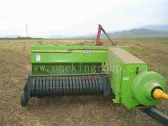
Features:
The tractor PTO operated machine consists of reel type straw pick up assembly, and straw compaction and tying units. It automatically picks up the residue straw from field with the help of reel which is transferred into bale chamber with the help of feeder and then straw is compressed with the reciprocating ram into a compact variable length size. It also automatically ties the knots using metal wire or nylon rope.
Specifications:  Length (mm)  Width (mm)  Height (mm)  Width of pick up reel  Number of knotters  Cross section of the bale chamber (mm)  Twine box capacity  No. of plunger strokes per minute  Plunger stroke length (mm)  Wheel tread (mm)  Flywheel diameter (mm)  Power Source (hp/kW) | : 5550  : 2600  : 1950  : 1540  : 2  : 400 x 460  : Four spools  : 75 at 2000 engine rpm  : 764  : 2100  : 560  : 35/26.5 or above tractor
Uses: Straw balers are used for baling of straw into bales of rectangular cross section.

Approx. Cost of Machine : Rs. 7,00,000/-

9.1 | Multi-crop Thresher
9.2 | Axial-flow Paddy Thresher
9.3 | Maize de-husker cum Sheller

9.1 MULTI-CROP THRESHER

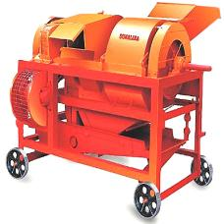
Features

The thresher consists of rasp bar threshing cylinder, oscillating sieves, concave and winnowing and cleaning attachment. The rasp-bar cylinder is made of cast iron rings, sheet metal and toothed racks and is fitted on the main shaft running on two heavy pedal bearings. Various pulleys of different sizes are fitted on this shaft to transmit power to winnowing and fan attachment. Adjustments for cylinder and blower speeds and concave clearance are provided to make the machines suitable for threshing various crops.

Specification  Diameter of beater shaft (mm)  Length of beater shaft (mm)  Diameter of cylinder with rasp-bar (mm)  Length of the cylinder(mm)  Height of hopper from ground level (mm)  Capacity (kg/h)  Power requirement (hp/kW) |  | : 42  : 1400  : 416  : 560  : 1500  : 600-1000  : 7.5/5.6
Uses: Suitable for threshing paddy, ragi, jowar, maize, sunflower, wheat, mustard etc.

Approx. Cost of Machine : Rs. 60,000 – 80,000/-

9.2 AXIAL-FLOW PADDY THRESHER

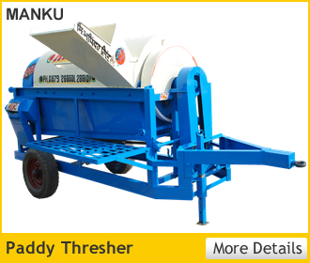
Features

It consists of a threshing cylinder, concave, cylinder casing, cleaning system and feeding chute. In axial flow concept, the crop is fed from one end, moves axially and the straw is thrown out from the other end after complete threshing of the crop. During threshing, the crop rotates three and half times around the cylinder and all the grains get detached. The threshing cylinder is of peg type. The casing of the thresher has 7 louvers for moving the crop axially. Two aspirator blowers and two sieves are provided for cleaning.

Specifications  Length (mm)  Width (mm)  Height(mm) :  Feeding device :  Length of feeding chute (mm) :  Width of feeding chute (mm)  Type of cylinder  Cylinder size, tip diameter x length(m m)  Length of concave (mm)  Width of concave (mm)  Concave clearance (mm)  Type, size and number of blowers  Weight (kg)  Power requirement(hp/kW) : |  | : 2030  : 3050  : 1960  : Feeding chute, manually  : 905  : 110  : Spike tooth  : 770 x 1500  : 840  : 570  : 18-21  : Aspirator type, two blowers of  400 mm diameter and 160 mm  width  : 730  : 35/26.25, tractor PTO
Uses: Used for threshing of paddy crop.
Approx. Cost of Machine : Rs. 80,000/-
9.3 MAIZE DE-HUSKER CUM SHELLER
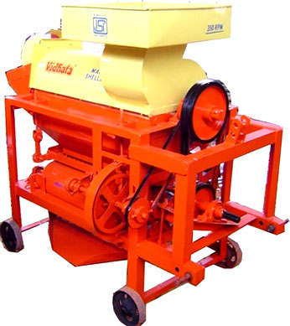
Features
Maize dehusker cum sheller are of two types namely, spike tooth type and axial flow type. In the spike tooth type sheller, pegs are staggered at varying heights for better shelling efficiency. The spikes are placed in 6 rows with 6 spikes in each row. The sieves have 1.25 cm diameter opening to separate the shelled maize from husk. In axial flow type threshers, pegs are provided on the cylinder and louvers were provided on the upper periphery of the drum to convey the crop to the outlet.

Specification  Length (mm)  Width (mm)  Height (mm)  Dia. of threshing cylinder (mm)  Length of threshing cylinder (mm)  Cylinder speed (m/s)  Type of threshing drum  Type of blower  No of sieves  Opening size of upper sieve (mm)  Opening size of lower sieve (mm)  Concave clearance (mm)  Opening size of concave (mm)  Moisture content of cobs(%)  Threshing Capacity(kg/h)  Power requirement(hp/kW) | Spike tooth type  1765  1065  1570  480  325  16.4  Spike tooth  centrifugal  2  12  2  50  5 x 5  12-28  450-650  35/26.25 |  | Axial type  3400  1140  2190  495  1460  13.7  Peg type  centrifugal  3  12.5  3  50  5.1 x 5.1  15-28  1200-2800  35/26.25
Uses: Used for threshing of maize cobs.

Approx. Cost of Machine : Rs. 60,000/-

S. No. | Manufacturers
 | Agro King Agricultural Implements, Karnal
 | Agro Engineers, Shyam Nagar, G.T. Road, Karnal
 | Advance Industries, Maneser Road, Gurgaon-122 001
 | Avtar Implements, G.T. Road, Palwal
 | Babbu Engg. Works, G.T. Road, Hodal
 | Bajaj Industries, G.T. Road Karnal
 | Batra Investments Pvt. Ltd, 14/1, Mathura Road, P.O. Amarnagar, Faridabad - 121 003
 | Beri Udyog Pvt. Ltd, GPO, Box-132, Karnal
 | Bharat Agro Foundry, G.T. Road, Karnal
 | Bharat Engg. Company, Shyam Nagar, G.T. Road, Karnal
 | Bhawna Industries, 8-A, Industrial Development Colony, Kunjpura Road, Karnal - 132 001,
 | Champion Agro. Industries, Namaste chowk, G.T.Road, Karnal
 | Chaudhary Charan Singh Haryana Agril. University, Hissar-125 004
 | Choudhary Agro Industries, Jhajjar Road, Sampla
 | Choudhary Engg. Works, Choudhary Bhawan, G.T. Road, Hodal, Faridabad
 | Dabur Industries.(India), Namaste Chowk, Karnal
 | Deepak Agriculture Works, Basi Road, Gurgaon
 | Department of microbiology, CCS Haryana Agricultural University, Hissar-125 003
 | Dinesh Agro Industies, G.T. Rd. Near Bus Stand, Hodal Distt. Faridabad
 | Escorts Limited, Agriculture Machinery Marketing Division, 18/4 Mathura Road, Faridabad-121 002
 | Gaba Agril. Implements, Shyam Nagar, G.T. Road, Karnal
 | Gas & Chemical Industries (P) Ltd. Works : 14/1 Mathura Road, Faridabad - 121 003
 | Giraj Engg. Works, Hodal
 | Harbans Lal Kundanlal, Haryana State Dairy Development Corporation, Karnal
 | Haryana Agril. Implements, Shyam Nagar, Karnal
 | Hindustan Foundry & Engg. Works, Railway Road, Sampla
 | Indian Agril. Implements, Namaste chowk, G.T. road, Karnal
 | Ishwar Agro Industries, Kharkhoda road, Sampla
 | Jai Kisan Agril Implements, Shyam Nagar. G.T. Road, Karnal
 | Jaibharat Engg. Works, Jhajjar Road, Sampla
 | Jaihind Works, Kharkhoda Road, Sampla
 | Jaminder Engg. Works, Kharkhoda Road, Sampla, Rohtak
 | Jhi Baba Mast Ram, Kharkhoda Road, Sampla
 | K.C. Agro Aids, Delhi By-pass G.T. Road, Karnal-132 001
 | Joonix India, S.C.O. 84, Sector 16, Faridabad-121 002
 | Kajala Agro Industries, Kharkhoda road, Sampla
 | Karnal Agril. Implement, Shyam Nagar. G.T.Road, Karnal
 | Kisan Agro Industries Jhajjhar Road, Sampla
 | Kissan Tractor Trading Co., Patudi Road, Haily Mandi, Gurgaon
 | Krishna Agro Indsutries, Palwal
 | Mahendra Agro Industries, G.T. Road, Hodal
 | Mittal Automobiles, Paltudi Road, Haily Mandi Gurgaon
 | Mitaso Appliances Ltd., Plot No. 63, Sec. 6, Faridabad - 121 006
 | Modern Industries, Vijay Nagar, G.T. Road, Karnal
 | New Aman Engg. Works, Kharkhoda Road, Sampla
 | New Trailer and Implements Corporation, Bhiwani Road, Rohtak
 | OSAW Agro Industries Pvt. Ltd., P.O. Bag No. 5, Osaw Complex, Jagadhri Road, Ambala Cantt-133 001
 | Oswal Electricals (Pumps), 71/3, Mile-Stone, G.T. Road, Delhi Side, Karnal-132 001
 | Pandaji Engg. Works,G.T. Road, Hodal
 | Pargati Gramodhog Mandal, 92, Auto Market, Hisar
 | Pratap Iron works, Kungpura Road, Karnal
 | Puran Engg. Works, G.T. Road, Hodal, Faridabad
 | Rajiv Farm Machinery, 146, Auto Market, Hisar
 | Ramshran Engg. Works, G.T. Road, Palwal
 | Rawat Engg. Works, Hodal
 | Rohtash Engg. Works, Hodal District Faridabad
 | RP Engineering Works, Balsamaud Road, Hisar
 | Sarjit Singh and Sons, Sohna mode, G.T. Road, Palwal
 | Satish Agro Industries, Kharhoda Road, Sampla
 | Satwant Agro Engineers, Opposite PSEB, Sangrur Road, Bhawanigarh – 148 026
 | Shri Om Agro Industries, Railway Road, Sampla, Rohtak
 | Sompal Engg. Works, Hodal, Faridabad
 | Su-Solartech Systems(P) Ltd., S.C.O., 184, Opposite Sports Complex, Sector7-C, Chandigarh-160 019
 | Sunflame Industries (P) Ltd, Shed No. 2, Plot No. 58, P.O. Amar Nagar Faridabad - 121 003
 | Super Agril. Industries, G.T. Road. Karnal, Near bus stand
 | Suraj Engg. Works, Kharkhoda Road, Sampla
 | Sweet Home Appliances Pvt. Ltd., 3-E/16, B.P.N.I.T. Faridabad-121 001
 | Tanwar Agro Indsutries, G.T. Road, Hodal, District Faridabad
 | The Haryana Krish Yantra Udyog, Haily Mandi, Gurgaon
 | The Oriental Science Apparatus Workshops(OSAW) , Jawaharlal Nehru Marg, Opposite Civil Hospital Ambala Cantt.-133 001
 | Triupati Udyog, HSIDC, Indst. Estate, Karnal
 | Vijay Krishi Udyog, G.T. Road, Hodal
 | Vikram Autowage, Jhajjar Road, Sampla, Rohtak
 | Vinod Engg. Works, Jhajjar Road, Sampla, Rohtak
 | Vishkarma Engg. Works, Distt. Faridabad Hodal

(a) Human Resources Development in Farm Mechanization:
Developing human resources and generation of self-employment by way of providing skill-oriented training in the agricultural sector is important aspect. Keeping this in view, Farm Machinery Training and Testing Institutes (FMTTIs) have been established at Budni (M.P.) in 1955, Hissar (Haryana) in 1963, Garladinne, District Anantapur in 1983 and Biswanath Chariali (Assam) in 1990. These Institutes have since then engaged in developing human resource for agricultural mechanization. The FMTTIs have been conducting different types of training programmes in the selection, operation, repair/maintenance and management of farm machinery for the benefit of nominees of Central/State Governments, Private Organization, retired/retiring Defence Personnel, technician, rural youth, farmers and engineering graduates. Trainees admitted under User Level Courses at these institutes are paid stipend @ Rs.1200/- per month per trainee to cover boarding expenses for a month and to defray to and fro travel expenditure, on actual basis by ordinary mode of transport.
To supplement efforts of FMTTIs in human resource development and to train large number of farmers at nearby places with a view to develop and improve upon technical know-how of users of agricultural implements and machines for its proper and effective utilization, Outsourcing of training is being done through institutions identified by State Governments such as State Agricultural Universities (SAUs), Agricultural Engineering Colleges, ICAR institutions, Polytechnics, etc. Financial assistance @ Rs. 5200/- per farmer per month is provided to institutions identified for training which includes stipend of Rs. 1200/- per farmer per month of training, actual to and fro travel expenses by ordinary mode of transport in ordinary class, upto maximum of Rs. 300/- per farmer, boarding and Lodging Charges @ Rs.1200/- per farmer per month and Institutional charges (including stationary, training material, honorarium) @ Rs. 2500/- per farmer per month.
(b) Quality control of agricultural machines and implements:
Improved and quality agricultural implements and machines play a pivotal role in sustainable development of agriculture and enhancement of crop productivity. Therefore, identification of quality and need based agricultural machines/equipments are of paramount importance. Quality is also a critical factor in accessing competitive new markets for the manufacturers. The FMTTIs have been engaged in testing of agricultural machines and implements with the objectives of assessing suitability of machines to Indian conditions, educating clientele on comparative performance of various machines, providing data and material to extension workers for guiding farmers, helping financial institutions in more effectively financing their schemes of assistance for procurement of machinery. The institutes also assist in grant of BIS Certification, contribute to export promotion through assessing conformity of product to ISO/OECD specifications and carry out Batch Testing programme to help manufacturers in product improvement thereby providing better equipment to farmers.

The Budni institute is the only National Designated Authority in the country to test tractors as per the OECD Standards. The Budni and Hissar Institutes have also been authorized for certifying the self propelled machines against the statutory requirements under Central Motor Vehicle Rules and the facility for testing of engines for emission of exhaust gases has been commissioned at Budni institute.

With a view to make available quality agricultural implements and machines to the farmers under various Government assisted programmes and schemes, the State Governments have been advised to ensure the quality of machines before they are supplied to the farmers. Keeping in view the huge demand for testing, the testing of some equipment has also been decentralized and the State Governments may test the equipment, if considered necessary, through institutions such as any Department of SAU, any Engineering College, Indian Council of Agricultural Research (ICAR) institutions, KVK or any other research institute designated by the State Governments to undertake such activity. The test reports released by these designated institutions may be relied upon by all the State Governments.
(c) Popularization of new technology agricultural machines:
For improving adoption of technologies for crop production, it is necessary to properly demonstrate utility of technologies to farmers for achieving higher production and productivity. Therefore, with objective of induction of improved/new technology in agricultural production system, demonstration of newly developed agricultural/ horticultural equipments at the farmers’ fields have been introduced 100% grant-in-aid is given to the implementing agencies i.e State Governments/UTs and Government organizations like ICAR and State Farm Corporation of India (SFCI)for procurement and demonstration of identified equipment.
(d) Incentives for purchase of agricultural machines implements:
In order to make available various agricultural implements and machines at cheaper rates, assistance in the form of subsidy @ 25%to 50% of the cost of equipment/machine with permissible ceiling limits is available to all category of farmers for the purchase of various agricultural equipments under various schemes of the Department of Agriculture and Cooperation such as Macro Management of Agriculture, National Food Security Mission, Rashtriya Krishi Vikas Yojana, National Horticulture Mission etc.
(e) Incentives for setting up of Custom Hiring Centres of Agricultural Machines:
Incentives in the form of subsidy is supported through the RKVY and Macro Management Schemes so that the established Farm Machinery Banks would make available costly equipment to the farmer and would supplement the efforts of the Government in extending appropriate mechanization in the country, make available different input supply and services to needy farmers, provide gainful employment to rural unemployed youth, resulting in timeliness of farm operations thus ultimately leading to increase in production and productivity.

(f) Promotion of Post Harvest Management

The post- harvest management is promoted by way of establishment of post harvest technologies in the production catchments under the bilateral agreement of ICAR and Self Help Group (SHG)/User Groups (UG) of farmers /Cooperative Societies of Farmers /Non-Governmental Organizations (NGOs) with 40% assistance from the Government and remaining 60% coming from the beneficiary.

Establishment of low cost PHT with Government assistance @ 40% of the total cost of technology/project is also supported and the technologies involving initial project investment upto Rs. 2 lakh may be opted by individual farmer.

Demonstration of the crop/area specific post harvest technologies is also being undertaken through State Governments, All India Coordinated Research Projects on Post Harvest Technology Centres and KVKs of ICAR, Council for Scientific and Industrial Research (CSIR) Extension Centres and State Agricultural Universities(SAUs). The Government provides 100 percent grant to meet the expenses towards purchase and establishment of technologies/equipments and contingency expenditures for demonstrations.

Financial assistance @ Rs. 2600/- per farmer per week and Rs. 3000/- per entrepreneur/scientist per week is also provided to the institutions identified for training of farmers, entrepreneurs and scientist on post harvest Management.
For details of the above initiatives please log in to http://www.agricoop.nic.in

